**Final Year Project Report**

**Project Name**

**Urdu app Assistant(okAmeer)**



**Project Advisor:**

**M.Nabeel**

**Submitted By:**

**Hamza rafiq**

**13005065233**

**Session**

**University of Management and Technology**

**C-II Johar Town Lahore Pakistan**

**Dedication**

## 

**Final Approval**

**Panel of Examiners**

* **Head of Department**  ______________________

Department of Computer Science

UMT Lahore

* **Program Director ( Final Year Projects)** ______________________

Department of Computer Science

UMT Lahore

* **Supervisor** ______________________

Department of Computer Science

UMT Lahore

* **Co-Supervisor** ______________________

**Project Title Urdu app assistant**

**Objective make android device to understand you and perform task**

**Undertaken by**

**Supervised by M.Nabeel**

**Starting Date**

**Completion Date 8/10/2017**

**Tools Used Android studio**

**Operating System Android**

**Plagairism ReportAbstract**

we have lots of personal assistant in these days SIRI, Google now is one on them they make life easy for those who have English accent, but when we Urdu speaking people try these assistant we never get great experience, some time they understand what we are say most of time they not understand the accent on our English, so I want to make the Urdu assistant that understand you and do simple task, my Assistant not voice regeneration, Currently, speech recognition is performed using Google's Android SDK, either on the client device or in the cloud. Recognized text is passed to our Assistant through on Activity Result java callback, then Assistant understand the command and trigger the appropriate intent, e.g. turn on flash light or play song

This system for all android users who can speak the Urdu, android have android OS running

Revision Chart

| Version | Primary Author(s) | Description of Version | Date Completed |
| --- | --- | --- | --- |
| Draft | Hamza rafiq |  | 7/30/2016 |
| Preliminary | Hamza rafiq |  | 8/10/2016 |
| Final | Hamza rafuq |  | 8/30/2016 |
| Revision 1 | Hamza rafiq |  | 12/12/2016 |
| Revision 2 | Hamza rafiq |  | 7/18/2017 |

Contents

Definitions and Acronyms 1

List of Figures 2

List of Tables 3

1. Introduction 4

1.1 Motivations 4

1.2 Project Overview 4

1.3 Problem Statement 4

1.4 Objectives 4

2. Domain Analysis 5

2.1 Customer 5

2.2 Stakeholders 5

2.3 Affected Groups with social or economic impact 5

2.4 Dependencies/ External Systems 5

2.5 Reference Documents 5

2.5.1 Related Projects 5

2.5.2 Feature Comparison 5

3. Requirements analysis 7

3.1 Requirements 7

3.2 List of Actors 8

3.3 List of use cases 8

3.4 System use case diagram 10

3.5 Extended use cases 11

3.6 User interfaces (mock screens) 38

4. Data flow diagram (optional) 41

5. System Design 42

5.1 System Architecture Diagram 42

5.2 Class Diagram 43

5.3 Sequence Diagrams 44

5.4 Collaboration Diagrams 44

5.5 ERD 44

5.6 Data Dictionary 45

6. Implementation details 46

6.1 Development Setup 46

6.2 Deployment setup 46

6.3 Algorithms 46

6.4 Constraints 46

6.4.1 Assumptions 46

6.4.2 System constraints 46

6.4.3 Restrictions 46

6.4.4 Limitations 46

7. Testing 47

7.1 Extended Test Cases 47

7.2 Decision Table 87

7.2.1 Code snippet 87

7.2.2 Decision coverage table 88

7.3 Traceability Matrix 88

7.3.1 RID vs UCID (requirements vs use cases) 88

7.3.2 Prototypes (RID vs PID) 90

7.3.3 Test Cases (RID vs TID) 90

7.3.4 Coverage (UCID vs TID) 90

8. Results/Output/Statistics 91

8.1 %completion 91

8.2 %accuracy 91

8.3 %correctness 91

9. Conclusion 92

10. Future work 93

11. Bibliography 94

11.1 Books 94

11.2 Journals 94

11.3 Articles 94

11.4 Research papers 94

11.5 Other References 94

12. Appendix 95

12.1 Glossary of terms 95

12.2 Pre-requisites 95

## 

## Definitions and Acronyms

|  |  |
| --- | --- |
| **Acronym** | **Definition** |
| GSR | Google speech recognition |
| JSON | Java Script Object Notation |

Table : table of acronyms and definitions

## List of Figures

Figure 1 use case 9

Figure 2: prototype 1 23

Figure 3: prototype 2 24

Figure 4 : DFD level 0 25

Figure 5: system Architecture Diagram 26

Figure 6: Class Diagram 27

Figure 7: Sequence Diagrams 28

Figure 8: EDR 29

## List of Tables

Table 1: table of acronyms and definitions 1

Table 2: list of stakeholders 5

Table 3 Feature Comparison 6

Table 4 Requirements 7

Table 5 Extended use cases 11

# Introduction

## Motivations

Like most of people I have also smart android phone and my smart phone have ability to do action on user command when I try to operate my smart phone on my command I cannot get any output result it is because I have not English accent or may other problem , I always want to use Google assistant , I am sure you also want use Google assistant witch you already have in your android device but the problem with our English accent our accent cannot understand Google vary easy, so I decide to make app that use the Google speech recognition and do action your command , I want to see how it look if I ask for paly a next song can my assistant play the next song?

## Project Overview

* Overview Statement

we have lots of personal assistant in these days Siri, Google now is one on them they make life easy for those who have English accent, but when we Urdu speaking people try these assistant we never get great experience, some time they understand what we are say most of time they not understand the accent on our English, so I want to make the Urdu assistant that understand you and do simple task, my Assistant not voice regeneration, Currently, speech recognition is performed using Google's Android SDK, either on the client device or in the cloud. Recognized text is passed to our Assistant through on Activity Result java callback, then Assistant understand the command context and trigger the appropriate intent, e.g. turn on flash light or weather report

This system for all android users who can speak the Urdu, android have android OS running 4.4.4

* Goals

With help of Google speech android SDK make android phone smarter so user can control his device using voice command

## Problem Statement

Google Assistant understand the only English and do task for you but I want to make personal android assistant witch work with Urdu and do simple task

## Objectives

Make world first Urdu Assistant

# Domain Analysis

## Customer

## Stakeholders

|  |  |
| --- | --- |
| **Stakeholder** | **Role in System** |
| Android regular user | Anybody have android mobile with android 4.4.4 or higher OS can use this system |

Table : list of stakeholders

## Affected Groups with social or economic impact

* Common android user

Command android user will directly affected by this app who want to really control android device by voice but can’t before because they not have English accent

* Admin

## Dependencies/ External Systems

* Speech recognition using Google's Android SDK
* Firebase database
* User have little knowledge of using android phone
* Internet

## Reference Documents

<https://www.apple.com/ios/siri/>

### Related Projects

Google Now:

Google Now is an intelligent personal assistant developed by Google. Google Now, including Now cards, voice search and commands, is available in the

Apple SIRI

### Feature Comparison

|  |  |  |  |  |  |
| --- | --- | --- | --- | --- | --- |
| Sr No. | Comparison Feature | Google Now/SIRI | Urdu Assistant |  |  |
| 1 | Ability to do task | When we try to use Google with English accent it work perfectly , but it fail when non English accent or non-English command given by user | Urdu assistant use the same Google speech recognition API to do simple task in Urdu witch Google now can’t able to-do |  |  |
| 2 | Request new Command | In Google now user can’t request new command | But here user can request new command or also can vote to existing commands |  |  |

Table Feature Comparison

# Requirements analysis

## Requirements

|  |  |
| --- | --- |
| Functional Requirements | 1. Sign Up 2. Log In 3. Request new Command 4. Vote for new Command 5. Turn on Flash light 6. Turn of flash light 7. Play song 8. Play song from YouTube 9. Next song 10. Previous song: 11. Stop music 12. Increase Volume 13. Decrease Volume 14. Send Gmail 15. Play song from YouTube 16. Send message 17. Cancel text message 18. Send What’s App message 19. Cancel what’s app message 20. Make phone call 21. Cancel phone call 22. Read unread message: 23. Skip unread message 24. Set Alarm: 25. Bluetooth on 26. Bluetooth off: 27. Turn on Wi-Fi: 28. Turn off Wi-Fi: 29. How to Use: |
| Non-Functional Requirements | Efficiency  Safety |
| Data Requirements |  |
| Constraints | * Reliable Internet Speed * Do only simple task * minSdkVersion 15 |

Table Requirements

## List of Actors

Regular Android user: anybody who have access to Google play store can become app user

Admin: the Admin can modify the command activation phrases

## List of use cases

1. Sign Up allow user to input the detail and give the access to Login
2. Log In; allow user to provide account information and access to the requires new command or vote for new command
3. Request new Command: allow user to Request new command to admin
4. Vote for new Command: allow user to cast vote on existing requested command by others
5. Turn on Flash light: allow user to turn on flashlight by sending broad cast intent to OS
6. Turn of flash light: allow user to turn of flashlight incase flash light already on
7. Play song: allow user to play song from locally
8. Play song from YouTube : allow user to play song from YouTube
9. Next song: allow user to play next song incase Audio manger already playing song, if this is last song then 1st song will play automatically
10. Previous song: allow user to play pervious song incase audio manger already playing song,
11. Stop music: stop music if already music is playing
12. Increase Volume: allow user to increase volume while playing song
13. Decrease Volume: allow user to decrease the volume
14. Send Gmail: send Gmail
15. Play song from YouTube: play song from YouTube by saying song name
16. Send message: user can send message to any saved number in his/her contact list
17. Cancel text message: user can cancel the text message while he paling to send text message
18. Send What’s App message: can send what’s app message to any what’s app number that store in phone contact list
19. Cancel what’s app message: user can cancel what’s app message if he/she don’t want to send it
20. Make phone call: user can make phone to any number, number should be store in phone contact list
21. Cancel phone call: user can cancel the phone call from cancel button inside the assistant call screen
22. Read unread message: user can hair the unread message
23. Skip unread message: user can skip the message if he/she don’t want to listen it
24. Set Alarm: user can set alarm (it is still in Beta)
25. Bluetooth on: user can turn on Bluetooth
26. Bluetooth off: user can turn off Bluetooth
27. Turn on Wi-Fi: user can turn on Wi-Fi
28. Turn off Wi-Fi: user can turn off Wi-Fi
29. How to Use: user can read the example command how to use this app e.g. help button

## System use case diagram

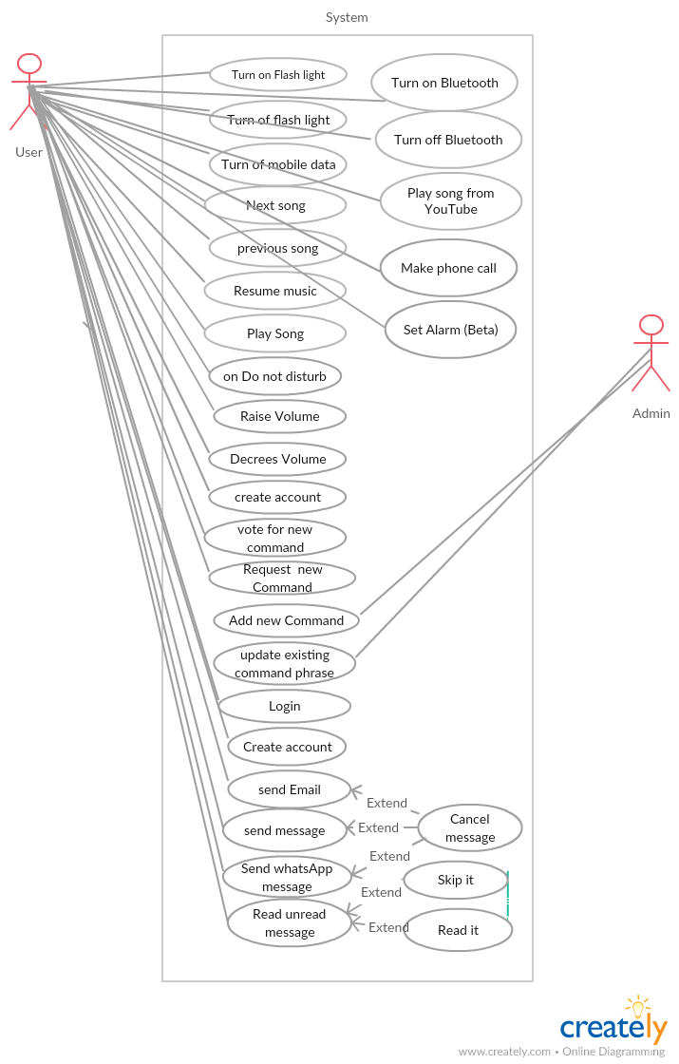

Figure use case

## Extended use cases

|  |  |  |  |  |
| --- | --- | --- | --- | --- |
| **Use Case ID:** | UC-1.3.1 | | | |
| **Use Case Name:** | Play Next Song | | | |
| **Created By:** | Hamza rafiq | | **Last Updated By:** |  |
| **Date Created:** | 1/26/2016 | | **Last Revision Date:** |  |
| **Actors:** | | Primary user  System Audio manger | | |
| **Description:** | | This use case will be start once user initiates the voice command by pressing the mic button from main screen , once Assistant is ready to accept the command, user give the voice input for play next song, Assistant will be play next song if user already playing song, in case if this is last song in user play list then 1st song will be play automatically, | | |
| **Trigger:** | | There will be one button to trigger the use case , Result of this use case will be Next song will be play from user play list | | |
| **Preconditions:** | | 1. User must have enable mobile data/Wi-Fi 2. User must give permission to Assistant to control his device on installing time 3. Audio manger must be active and playing the any song from Default google music app 4. User command should be relevant to this use case | | |
| **Post conditions:** | | 1. Next song will be tuned 2. User will navigate to home screen 3. Microphone should not use by other apps | | |
| **Normal Flow:** | | 1. User open the assistant by clicking on icon or user could Request to Google now to start the assistant 2. Once user Assistant initiate user will able to give the command / use may need to initiate Assistant manually by click on mic button inside the Assistant UI 3. Assistant will Request google voice recognition to initiate the mic and ready to Accept the command 4. google voice recognition will recognize the command and give back result to Assistant in String 5. Now Assistant try to find command from database 6. Once user give command match to the play next song context 7. Assistant will request to default android Audio manger to play next song 8. Audio manger will play next song | | |
| **Alternative Flows:** | | 1. 3a. In step 3 google voice recognition request to mic if mic are used by other party it Assistant may not able to get command from user and Assistant state will be not change 2. 4a. in step 4 google voice recognition need data connection to recognize the voice , but if you have not active connection it may not be able to recognize the voice signal , in that case user will be successfully register the command but not able to get any output form Assistant side 3. 6a. If user command not match to user any command Assistant will display shot massage to user for repeat the command 4. 7a. if user not using the default audio player Assistant may not able to play the song, in that case command is execute but output will be zero | | |

Table Extended use cases

|  |  |  |  |  |
| --- | --- | --- | --- | --- |
| **Use Case ID:** | UC-1.3.2 | | | |
| **Use Case Name:** | Turn of flash light | | | |
| **Created By:** | Hamza rafiq | | **Last Updated By:** |  |
| **Date Created:** | 1/26/2016 | | **Last Revision Date:** |  |
| **Actors:** | | Primary user | | |
| **Description:** | | This use case will be start once user initiates the voice command by pressing the mic button from main screen , once Assistant is ready to accept the command, user give the voice input for turning of flash light, app will turn of flash light if flash light already on | | |
| **Trigger:** | | There will be one button to trigger the use case , Result of this use case will be Turing off flash light | | |
| **Preconditions:** | | 1. User must have enable mobile data/Wi-Fi 2. User must give permission to Assistant to control his device on installing time 3. Flash light must be turn on already 4. User command should be relevant to this use case 5. Microphone should not use by other apps | | |
| **Post conditions:** | | 1. Flash light will be off 2. User will navigate to home screen | | |
| **Normal Flow:** | | 1. User open the assistant by clicking on icon or user could Request to Google now to start the assistant 2. Once user Assistant initiate user will able to give the command / use may need to initiate Assistant manually by click on mic button inside the Assistant UI 3. Assistant will Request google voice recognition to initiate the mic and ready to Accept the command 4. google voice recognition will recognize the command and give back result to Assistant in String 5. Now Assistant try to find command from database 6. Once user give command match to the flash light context 7. Assistant will turn of flash light | | |
| **Alternative Flows:** | | 1. 3a. In step 3 google voice recognition request to mic if mic are used by other party it Assistant may not able to get command from user and Assistant state will be not change 2. 4a. in step 4 google voice recognition need data connection to recognize the voice , but if you have not active connection it may not be able to recognize the voice signal , in that case user will be successfully register the command but not able to get any output form Assistant side | | |
| **Exceptions:** | | 1. 3a. If mic are used by other party then user get exception mic may not A/v 2. 4a. step for GVR need internet connection but if user not have active connection user may get Network not A/V | | |
| **Includes:** | |  | | |
| **Frequency of Use:** | |  | | |
| **Special Requirements:** | | 1. Android API leave 22+ | | |
| **Assumptions:** | | 1. Flash Light already turn on 2. User have Reliable speed of internet 3. User mobile have Android API 22+ 4. User have GVR install 5. User have unlocked device 6. User give permission to assistant to access the flash light | | |
| **Notes and Issues:** | | 1. Due to bad/slow internet connection Assistant may not behave normal | | |
|  | |  | | |

|  |  |
| --- | --- |
| **Exceptions:** | 1. 3a. If mic are used by other party then user get exception mic may not A/v 2. 4a. step for GVR need internet connection but if user not have active connection user may get Network not A/V 3. If user command not match to any command user will get a exception it may call command not found |
| **Includes:** |  |
| **Frequency of Use:** |  |
| **Special Requirements:** | 1. Android API leave 22+ |
| **Assumptions:** | 1. User already ready playing the Audio song from default android Audio app 2. User have Reliable speed of internet 3. User mobile have Android API 22+ 4. User have GVR install 5. User have unlocked device 6. User give permission to assistant to access the audio manger |
| **Notes and Issues:** | 1. Due to bad/slow internet connection Assistant may not behave normal |

|  |  |  |  |  |
| --- | --- | --- | --- | --- |
| **Use Case ID:** | UC-1.3.3 | | | |
| **Use Case Name:** | Turn on flash light | | | |
| **Created By:** | Hamza | | **Last Updated By:** |  |
| **Date Created:** | 1/25/2016 | | **Last Revision Date:** |  |
| **Actors:** | | Primary user | | |
| **Description:** | | This use case will start once user initiates the voice command, once user give the voice input for turning on flash light, app will turn on flash light if flash light already of | | |
| **Trigger:** | | There will be once button to trigger the use case, but user also initiate the use case from Google now launcher by saying app name | | |
| **Preconditions:** | | 1. User must have enable mobile data/Wi-Fi 2. User must give permission to this app on installing time 3. Flash light must be turn off 4. User command should be relevant to this use case | | |
| **Post conditions:** | | 1. Flash light will be on 2. User will navigate to home screen | | |
| **Normal Flow:** | | 1. User open the assistant by clicking on icon or user could Request to Google now to start the assistant 2. Once user Assistant initiate user will able to give the command / use may need to initiate Assistant manually by click on mic button inside the Assistant UI 3. Assistant will Request google voice recognition to initiate the mic and ready to Accept the command 4. google voice recognition will recognized the command and give back result to Assistant in String 5. Now Assistant try to find command from database 6. Once user given command match to the flash light context 7. Assistant will turn on flash light | | |
| **Alternative Flows:** | | 1. 3a. In step 3 google voice recognition request to mic if mic are used by other party it Assistant may not able to get command from user and through Exp 2. 4a. in step 4 google voice recognition need data connection to recognize the voice , but if you have not active connection it may not be able to recognize the voice signal | | |
| **Exceptions:** | | 1. 3a. If mic are used by other party then user get exception mic may not A/v 2. 4a. step for GVR need internet connection but if user not have active connection user may get Network not A/V | | |
| **Includes:** | |  | | |
| **Frequency of Use:** | |  | | |
| **Special Requirements:** | | 1. Android API leave 22+ | | |
| **Assumptions:** | | 1. Flash Light already turn of 2. User have Reliable speed of internet 3. User mobile have Android API 22+ 4. User have GSR install 5. User have unlock device 6. User give permission to assistant to access the flash light | | |
| **Notes and Issues:** | | 1. Due to bad/slow internet connection Assistant may not behave normal | | |

|  |  |  |  |  |
| --- | --- | --- | --- | --- |
| **Use Case ID:** | UC-1.3.4 | | | |
| **Use Case Name:** | Play previous Song | | | |
| **Created By:** | Hamza rafiq | | **Last Updated By:** |  |
| **Date Created:** | 1/26/2016 | | **Last Revision Date:** |  |
| **Actors:** | | Primary user  System Audio manger | | |
| **Description:** | | This use case will be start once user initiates the voice command by pressing the mic button from main screen , once Assistant is ready to accept the command, user give the voice input for play previous song, Assistant will be play previous song if user already playing song , aka System Audio manger active , in case if this is last song in user play list then it will be loop back , | | |
| **Trigger:** | | There will be one button to trigger the use case , Result of this use case will be Next song will be play from user play list | | |
| **Preconditions:** | | 1. User must have enable mobile data/Wi-Fi 2. User must give permission to Assistant to control his device on installing time 3. Audio manger must be active and playing the any song from Default google music app 4. User command should be relevant to this use case 5. Microphone should not use by other apps | | |
| **Post conditions:** | | 1. Next song will be tuned 2. User will navigate to home screen | | |
| **Normal Flow:** | | 1. User open the assistant by clicking on icon or user could Request to Google now to start the assistant 2. Once user Assistant initiate user will able to give the command / use may need to initiate Assistant manually by click on mic button inside the Assistant UI 3. Assistant will Request google voice recognition to initiate the mic and ready to Accept the command 4. google voice recognition will recognize the command and give back result to Assistant in String 5. Now Assistant try to find command from database 6. Once user given command match to the play next song context 7. Assistant will request to default android Audio manger to play next song 8. Audio manger will play previous song | | |
| **Alternative Flows:** | | 1. 3a. In step 3 google voice recognition request to mic if mic are used by other party it Assistant may not able to get command from user and Assistant state will be not change 2. 4a. in step 4 google voice recognition need data connection to recognize the voice , but if you have not active connection it may not be able to recognize the voice signal , in that case user will be successfully register the command but not able to get any output form Assistant side 3. 6a. If user command not match to user any command Assistant will display shot massage to user for repeat the command 4. 7a. if user not using the default audio player Assistant may not able to play the song, in that case command is execute but output will be zero | | |
| **Exceptions:** | | 1. 3a. If mic are used by other party then user get exception mic may not A/v 2. 4a. step for GVR need internet connection but if user not have active connection user may get Network not A/V 3. If user command not match to any command user will get a exception it may call command not found | | |
| **Includes:** | |  | | |
| **Frequency of Use:** | |  | | |
| **Special Requirements:** | | 1. Android API leave 22+ | | |
| **Assumptions:** | | 1. User already ready playing the Audio song from default android Audio app 2. User not playing the 1st song from his playlist 3. User have Reliable speed of internet 4. User mobile have Android API 22+ 5. User have GVR install 6. User have unlocked device 7. User give permission to assistant to access the audio manger | | |
| **Notes and Issues:** | | 1. Due to bad/slow internet connection Assistant may not behave normal | | |

|  |  |  |  |  |
| --- | --- | --- | --- | --- |
| **Use Case ID:** | UC-1.3.5 | | | |
| **Use Case Name:** | Resume Song | | | |
| **Created By:** | Hamza rafiq | | **Last Updated By:** |  |
| **Date Created:** | 1/26/2016 | | **Last Revision Date:** |  |
| **Actors:** | | Primary user  System Audio manger | | |
| **Description:** | | This use case will be start once user initiates the voice command by pressing the mic button from main screen , once Assistant is ready to accept the command, user give the voice input for Resume the song with already stop by user , Assistant will be resume the song if user already stop song , aka System Audio manger active and it is in passed state ,, | | |
| **Trigger:** | | There will be one button to trigger the use case , Result of this use case will be resume the song witch is passed by user and active in background service | | |
| **Preconditions:** | | 1. User must have enable mobile data/Wi-Fi 2. User must give permission to Assistant to control his device on installing time 3. Audio manger must be active and in pass state 4. Song must be active in background service in pass state 5. User must not be streaming the music on any online app 6. To complete this action, it may need to have install Default google music app 7. User command should be relevant to this use case 8. Microphone should not use by other apps | | |
| **Post conditions:** | | 1. Song will be resume 2. User will navigate to home screen | | |
| **Normal Flow:** | | 1. User open the assistant by clicking on icon or user could Request to Google now to start the assistant 2. Once user Assistant initiate user will able to give the command / use may need to initiate Assistant manually by click on mic button inside the Assistant UI 3. Assistant will Request google voice recognition to initiate the mic and ready to Accept the command 4. google voice recognition will recognize the command and give back result to Assistant in String 5. Now Assistant try to find command from database 6. Once user given command match to the resume the song context 7. Assistant will request to default android Audio manger to resume the song 8. Audio manger will play song | | |
| **Alternative Flows:** | | 1. 3a. In step 3 google voice recognition request to mic if mic are used by other party it Assistant may not able to get command from user and Assistant state will be not change 2. 4a. in step 4 google voice recognition need data connection to recognize the voice, but if you have not active connection it may not be able to recognize the voice signal , in that case user will be successfully register the command but not able to get any output form Assistant side 3. 6a. If user command not match to user any command Assistant will display shot massage to user for repeat the command 4. 7a. if user not using the default audio player Assistant may not able to resume the song, in that case command is execute but output will be zero | | |
| **Exceptions:** | | 1. 3a. If mic are used by other party then user get exception mic may not A/v 2. 4a. step for GVR need internet connection but if user not have active connection user may get Network not A/V 3. If user command not match to any command user will get a exception it may call command not found | | |
| **Includes:** | |  | | |
| **Frequency of Use:** | |  | | |
| **Special Requirements:** | | 1. Android API leave 22+ | | |
| **Assumptions:** | | 1. User already stop the any song from default android Audio app and it active in background service 2. User not playing the 1st song from his playlist 3. User have Reliable speed of internet 4. User mobile have Android API 22+ 5. User have GVR install 6. User have unlocked device 7. User give permission to assistant to access the audio manger | | |
| **Notes and Issues:** | | 1. Due to bad/slow internet connection Assistant may not behave normal | | |

|  |  |  |  |  |
| --- | --- | --- | --- | --- |
| **Use Case ID:** | UC-1.3.6 | | | |
| **Use Case Name:** | Stop song | | | |
| **Created By:** | Hamza rafiq | | **Last Updated By:** |  |
| **Date Created:** | 1/26/2016 | | **Last Revision Date:** |  |
| **Actors:** | | Primary user  System Audio manger | | |
| **Description:** | | This use case will be start once user initiates the voice command by pressing the mic button from main screen , once Assistant is ready to accept the command, user give the voice input for stop the song witch already running , Assistant will be stop the song if user already playing song , aka System Audio manger deactivate | | |
| **Trigger:** | | There will be one button to trigger the use case , Result of this use case will be stop the song witch is playing by user already | | |
| **Preconditions:** | | 1. User must have enable mobile data/Wi-Fi 2. User must give permission to Assistant to control his device on installing time 3. Audio manger must be active and in pass state 4. Song must be active in background service in pass state 5. User must not be streaming the music on any online app 6. To complete this action, it may need to have install default music player app by android os from google 7. User command should be relevant to this use case 8. Microphone should not use by other apps | | |
| **Post conditions:** | | 1. Song will be resume 2. User will navigate to home screen | | |
| **Normal Flow:** | | 1. User open the assistant by clicking on icon or user could Request to Google now to start the assistant 2. Once user Assistant initiate user will able to give the command / use may need to initiate Assistant manually by click on mic button inside the Assistant UI 3. Assistant will Request google voice recognition to initiate the mic and ready to Accept the command 4. google voice recognition will recognize the command and give back result to Assistant in String 5. Now Assistant try to find command from database contest 6. Once user given command match to the stop the song context 7. Assistant will request to default android Audio manger to stop the song 8. Audio manger will be stop | | |
| **Alternative Flows:** | | 1. 3a. In step 3 google voice recognition request to mic if mic are used by other party it Assistant may not able to get command from user and Assistant state will be not change 2. 4a. in step 4 google voice recognition need data connection to recognize the voice, but if you have not active connection it may not be able to recognize the voice signal , in that case user will be successfully register the command but not able to get any output form Assistant side 3. 6a. If user command not match to user any command Assistant will display shot massage to user for repeat the command 4. 7a. if user not using the default audio player Assistant may not able to stop the song, in that case command is execute but output will be zero | | |
| **Exceptions:** | | 1. 3a. If mic are used by other party then user get exception mic may not A/v 2. 4a. step for GVR need internet connection but if user not have active connection user may get Network not A/V 3. If user command not match to any command user will get a exception it may call command not found | | |
| **Includes:** | |  | | |
| **Frequency of Use:** | |  | | |
| **Special Requirements:** | | 1. Android API leave 22+ | | |
| **Assumptions:** | | 1. User already playing the any song from default android Audio app and it active in background service 2. User have Reliable speed of internet 3. User mobile have Android API 22+ 4. User have GVR install 5. User have unlocked device 6. User give permission to assistant to access the audio manger | | |
| **Notes and Issues:** | | 1. Due to bad/slow internet connection Assistant may not behave normal | | |

|  |  |  |  |  |
| --- | --- | --- | --- | --- |
| **Use Case ID:** | UC-1.3.7 | | | |
| **Use Case Name:** | Do Not disturb mood Aka good night | | | |
| **Created By:** | Hamza rafiq | | **Last Updated By:** |  |
| **Date Created:** | 1/26/2016 | | **Last Revision Date:** |  |
| **Actors:** | | Primary user  Notification Manager | | |
| **Description:** | | This use case will be start once user initiates the voice command by pressing the mic button from main screen , once Assistant is ready to accept the command, user give the voice input for DOT(Good night mood) assistant will request to Notification manger to enable the Do not disturb mood, | | |
| **Trigger:** | | There will be one button to trigger the use case , Result of this use case will be enable the do not disturb mood and all call and notification will be going to silence , and the | | |
| **Preconditions:** | | 1. User must have enable mobile data/Wi-Fi 2. User must give permission to Assistant to control his device on installing time 3. Do not disturb already of 4. User device must have install android version 5..1.1 or higher 5. User command should be relevant to this use case 6. Microphone should not use by other apps | | |
| **Post conditions:** | | 1. Do not disturb me mood will be on 2. All incoming calls and notification will be going to silence mode except those number adds as a exceptions 3. User will navigate to home screen | | |
| **Normal Flow:** | | 1. User open the assistant by clicking on icon or user could Request to Google now to start the assistant 2. Once user Assistant initiate user will able to give the command / use may need to initiate Assistant manually by click on mic button inside the Assistant UI 3. Assistant will Request google voice recognition to initiate the mic and ready to Accept the command 4. google voice recognition will recognize the command and give back result to Assistant in String 5. Now Assistant try to find command from database 6. Once user given command match to the do not disturb me command context 7. Assistant will request to notification manger to silence all the notification including calls | | |
| **Alternative Flows:** | | 1. 3a. In step 3 google voice recognition request to mic if mic are used by other party it Assistant may not able to get command from user and Assistant state will be not change 2. 4a. in step 4 google voice recognition need data connection to recognize the voice, but if you have not active connection it may not be able to recognize the voice signal , in that case user will be successfully register the command but not able to get any output form Assistant side 3. 6a. If user command not match to user any command Assistant will display shot massage to user for repeat the command 4. if user device running < lollipop OS then user will get error and user may not able to turn on do not disturb me mode 5. if user trying to activate do not disturb mode first time user may need to configure the some setting e.g. adding the notification priorities for some numbers | | |
| **Exceptions:** | | 1. 3a. If mic are used by other party then user get exception mic may not A/v 2. 4a. step for GVR need internet connection but if user not have active connection user may get Network not A/V 3. If user command not match to any command user will get a exception it may command not found 4. If user device not sported to do not disturb mode user may get action not found | | |
| **Includes:** | |  | | |
| **Frequency of Use:** | |  | | |
| **Special Requirements:** | | 1. Android API leave 22+ | | |
| **Assumptions:** | | 1. User have Reliable speed of internet 2. User device have do not disturb mode 3. User mobile have Android API 22+ 4. User have GVR install 5. User have unlocked device 6. User already configure the do not disturb mode 7. User give permission to assistant to access the audio manger | | |
| **Notes and Issues:** | | 1. Due to bad/slow internet connection Assistant may not behave normal | | |

|  |  |  |  |  |
| --- | --- | --- | --- | --- |
| **Use Case ID:** | UC-1.3.8 | | | |
| **Use Case Name:** | Play song from YouTube | | | |
| **Created By:** | Hamza rafiq | | **Last Updated By:** |  |
| **Date Created:** | 1/26/2016 | | **Last Revision Date:** |  |
| **Actors:** | | Primary user | | |
| **Description:** | | This use case will be start once user initiates the voice command by pressing the mic button from main screen , once Assistant is ready to accept the command, user give the voice input for play song from YouTube, Assistant send Query to YouTube API if there is response from YouTube api, assistant get video ID from response and request to YouTube play to play song | | |
| **Trigger:** | | There will be one button to trigger the use case, ass soon ass Assistant able to get video ID from YouTube api this Result will be play song from YouTube | | |
| **Preconditions:** | | * User must have enable mobile data/Wi-Fi * User must give permission to Assistant to control his device on installing time * User must say correct name of song that can be store on YouTube server * User must have v4.2.16 of the mobile YouTube app install | | |
| **Post conditions:** | | 1. Song will be played 2. YouTube player take whole screen to play 3. User no logger able to give voice command until song is playing | | |
| **Normal Flow:** | | 1. User open the assistant by clicking on icon or user could Request to Google now to start the assistant 2. Once user Assistant initiate user will able to give the command / use may need to initiate Assistant manually by click on mic button inside the Assistant UI 3. Assistant will Request google voice recognition to initiate the mic and ready to Accept the command 4. google voice recognition will recognize the command and give back result to Assistant in String 5. Now Assistant try to find command from database 6. Once user given command match with play song from YouTube 7. Assistant will send Query to YouTube Api, and get back JSON response 8. Once Assistant get video id from response Now Assistant pas that video to video play to play song | | |
| **Alternative Flows:** | | 1. 3a. In step 3 google voice recognition request to mic if mic are used by other party it Assistant may not able to get command from user and Assistant state will be not change 2. 4a. in step 4 google voice recognition need data connection to recognize the voice, but if you have not active connection it may not be able to recognize the voice signal , in that case user will be successfully register the command but not able to get any output form Assistant side 3. 6a. If user command not match to user any command Assistant will display shot massage to user for repeat the command 4. 8a. if user does not give current name of song, app may play unknown video | | |
| **Exceptions:** | | 1. 3a. If mic are used by other party then user get exception mic may not A/v 2. 4a. step for GVR need internet connection but if user not have active connection user may get Network not A/V 3. If user command not match to any command user will get a exception it may command not found 4. If user lose the internet connect during the YouTube api call user may get connect error | | |
| **Includes:** | |  | | |
| **Frequency of Use:** | |  | | |
| **Special Requirements:** | | 1. Android API leave 22+ | | |
| **Assumptions:** | | 1. User have Reliable speed of internet 2. User mobile have Android API 22+ 3. User have GVR install 4. User have unlocked device 5. User can input the correct song name | | |
| **Notes and Issues:** | | 1. Due to bad/slow internet connection Assistant may not behave normal | | |

|  |  |  |  |  |
| --- | --- | --- | --- | --- |
| **Use Case ID:** | UC-1.3.9 | | | |
| **Use Case Name:** | Send message | | | |
| **Created By:** | Hamza rafiq | | **Last Updated By:** |  |
| **Date Created:** | 7/25/2017 | | **Last Revision Date:** |  |
| **Actors:** | | Primary user | | |
| **Description:** | | This use case will be start once user initiates the voice command by pressing the mic button from main screen , once Assistant is ready to accept the command, user give the voice input for to write message as soon as message command match to command assistant will ask recipient name if name found in user mobile phone contact list Assistant will as for message other hand if user give wrong name assistant ask to retry | | |
| **Trigger:** | | The use case will be trigger once user says voice Query contains sms or message keyword | | |
| **Preconditions:** | | 1. User must have enable mobile data/Wi-Fi 2. User must give permission to Assistant to control his device on installing time /or run time 3. User must have saved recipient contact name in Roman Urdu 4. Microphone should not use by other apps | | |
| **Post conditions:** | | 1. Message will be send after 3s once user complete his messing voice input 2. User again navigate to home screen once message delivered 3. Newly sanded message will be seen in user default messaging app | | |
| **Normal Flow:** | | 1. User open the assistant by clicking on icon or user could Request to Google now to start the assistant 2. Once user Assistant initiate user will able to give the command / use may need to initiate Assistant manually by click on mic button inside the Assistant UI 3. Assistant will Request google voice recognition to initiate the mic and ready to Accept the command 4. google voice recognition will recognize the command and give back result to Assistant in String 5. Now Assistant try to find command from database 6. Once user given command match send SMS command 7. Assistant will ask for recipient name 8. Once assistant have recipient name match to user contact list 9. Assistant will now ask for message 10. After sending message user navigate to home screen | | |
| **Alternative Flows:** | | 1. 3a. In step 3 google voice recognition request to mic if mic are used by other party it Assistant may not able to get command from user and Assistant state will be not change 2. 4a. in step 4 google voice recognition need data connection to recognize the voice, but if you have not active connection it may not be able to recognize the voice signal , in that case user will be successfully register the command but not able to get any output form Assistant side 3. 6a. If user command not match to user any command Assistant will display shot massage to user for repeat the command 4. 7a.if user give name that not found in user phone contact list assistant again ask for name until user not give correct name 5. 7a.if user does not give Query within few second assistant will stop recognizer user may need restart voice recognizer manually 6. 9a.if user does not give Query within few second assistant will stop recognizer user may need restart voice recognizer manually | | |
| **Exceptions:** | | 1. 3a. If mic are used by other party then user get exception mic may not A/v 2. 4a. step for GVR need internet connection but if user not have active connection user may get Network not A/V 3. If user command not match to any command user will get a exception it may command not found 4. 7a,9a..if user does not give Query within few second assistant will stop recognizer may send error code 7 | | |
| **Includes:** | |  | | |
| **Frequency of Use:** | |  | | |
| **Special Requirements:** | |  | | |
| **Assumptions:** | | 1. User have Reliable speed of internet 2. User mobile have Android API 22+ 3. User have GVR install 4. User have unlocked device 5. User already saved recipient name in roman Urdu in contact phone list | | |
| **Notes and Issues:** | | 1. Due to bad/slow internet connection Assistant may not behave normal | | |

|  |  |  |  |  |
| --- | --- | --- | --- | --- |
| **Use Case ID:** | UC-1.3.10 | | | |
| **Use Case Name:** | Send Gmail | | | |
| **Created By:** | Hamza rafiq | | **Last Updated By:** |  |
| **Date Created:** | 7/25/2017 | | **Last Revision Date:** |  |
| **Actors:** | | Primary user | | |
| **Description:** | | This use case will be start once user initiates the voice command by pressing the mic button from main screen , once Assistant is ready to accept the command, user give the voice input for to write Emil as soon as email command match to command, assistant will ask recipient name if name found in user mobile phone contact list Assistant will Ask for email and start Gmail app intent along will recipient name and email message | | |
| **Trigger:** | | The use case will be trigger once user says voice Query contains Gmail or Email keyword | | |
| **Preconditions:** | | 1. User must have enable mobile data/Wi-Fi 2. User must give permission to Assistant to control his device on installing time /or run time 3. User must have saved recipient email in contact 4. User must have Login to Gmail official app with at least one account 5. Microphone should not use by other apps | | |
| **Post conditions:** | | 1. Email will be send after 3s once user complete his email voice input 2. User navigate to Gmail official app along with email body and recipient name | | |
| **Normal Flow:** | | 1. User open the assistant by clicking on icon or user could Request to Google now to start the assistant 2. Once user Assistant initiate user will able to give the command / use may need to initiate Assistant manually by click on mic button inside the Assistant UI 3. Assistant will Request google voice recognition to initiate the mic and ready to Accept the command 4. google voice recognition will recognize the command and give back result to Assistant in String 5. Now Assistant try to find command from database 6. Once user given command match send Gmail command 7. Assistant will ask for recipient name 8. Once assistant have recipient name match to user contact list 9. Assistant ask for Email body and then send intent to Gmail to along will name and body 10. Once android OS open Gmail official app user have to press send button in order to send email | | |
| **Alternative Flows:** | | 1. 3a. In step 3 google voice recognition request to mic if mic are used by other party it Assistant may not able to get command from user and Assistant state will be not change 2. 4a. in step 4 google voice recognition need data connection to recognize the voice, but if you have not active connection it may not be able to recognize the voice signal , in that case user will be successfully register the command but not able to get any output form Assistant side 3. 6a. If user command not match to user any command Assistant will display shot massage to user for repeat the command 4. 7a.if user give name that not found in user phone contact list assistant again ask for name until user not give correct name 5. 7a.if user does not give Query within few second assistant will stop recognizer back to last screen then user may need restart voice recognizer manually 6. 9a.Assistant try to send Email intent to official Gmail if Gmail app not found in user phone user may get Activity Not Found Ex and lead to crash | | |
| **Exceptions:** | | 1. 3a. If mic are used by other party then user get exception mic may not A/v 2. 4a. step for GVR need internet connection but if user not have active connection user may get Network not A/V 3. If user command not match to any command user will get a exception it may call command not found 4. 7a,9a..if user does not give Query within few second assistant will stop recognizer may send error code 7 5. 9a. if Gmail app not found in user phone user may get Activity Not Found Ex and lead to crash | | |
| **Includes:** | |  | | |
| **Frequency of Use:** | |  | | |
| **Special Requirements:** | |  | | |
| **Assumptions:** | | 1. User have Reliable speed of internet 2. User mobile have Android API 15+ 3. User have GVR install 4. User have unlocked device 5. User already saved recipient Email in roman Urdu in contact phone list 6. User have Install official Gmail app and Login to Gmail account | | |
| **Notes and Issues:** | | 1. Due to bad/slow internet connection Assistant may not behave normal 2. If user have login more than one Gmail account in his device Assistant will use primary email | | |

|  |  |  |  |  |
| --- | --- | --- | --- | --- |
| **Use Case ID:** | UC-1.3.11 | | | |
| **Use Case Name:** | Make phone call | | | |
| **Created By:** | Hamza rafiq | | **Last Updated By:** |  |
| **Date Created:** | 7/25/2017 | | **Last Revision Date:** |  |
| **Actors:** | | Primary user | | |
| **Description:** | | This use case will be start once user initiates the voice command by pressing the mic button from main screen , once Assistant is ready to accept the command, user give the voice input for to make phone call as soon as call command found, assistant will ask recipient name if name found in user mobile phone contact list Assistant will Ask for email and start Gmail app intent along will recipient name and email message | | |
| **Trigger:** | | The use case will be trigger once user says voice Query contains sms or message keyword | | |
| **Preconditions:** | | 1. User must have enable mobile data/Wi-Fi 2. User must give permission to Assistant to control his device on installing time /or run time 3. User must have saved recipient contact name in Roman Urdu 4. Microphone should not use by other apps | | |
| **Post conditions:** | | 1. call will be send after 3s once user complete his call voice input 2. User again navigate to calling screen | | |
| **Normal Flow:** | | 1. User open the assistant by clicking on icon or user could Request to Google now to start the assistant 2. Once user Assistant initiate user will able to give the command / use may need to initiate Assistant manually by click on mic button inside the Assistant UI 3. Assistant will Request google voice recognition to initiate the mic and ready to Accept the command 4. google voice recognition will recognize the command and give back result to Assistant in String 5. Now Assistant try to find command from database 6. Once user given command match to make phone call command 7. Assistant will ask for recipient name 8. Once assistant have recipient name match to user contact list 9. Assistant will start calling intent | | |
| **Alternative Flows:** | | 1. 3a. In step 3 google voice recognition request to mic if mic are used by other party it Assistant may not able to get command from user and Assistant state will be not change 2. 4a. in step 4 google voice recognition need data connection to recognize the voice, but if you have not active connection it may not be able to recognize the voice signal , in that case user will be successfully register the command but not able to get any output form Assistant side 3. 6a. If user command not match to user any command Assistant will display shot massage to user for repeat the command 4. 7a.if user give name that not found in user phone contact list assistant again ask for name until user not give correct name 5. 7a.if user does not give Query within few second assistant will stop recognizer back to last screen then user may need restart voice recognizer manually | | |
| **Exceptions:** | | 1. 3a. If mic are used by other party then user get exception mic may not A/v 2. 4a. step for GVR need internet connection but if user not have active connection user may get Network not A/V 3. If user command not match to any command user will get a exception it may call command not found 4. 7a,9a..if user does not give Query within few second assistant will stop recognizer may send error code 7 | | |
| **Includes:** | |  | | |
| **Frequency of Use:** | |  | | |
| **Special Requirements:** | |  | | |
| **Assumptions:** | | 1. User have Reliable speed of internet 2. User mobile have Android API 15+ 3. User have GVR install 4. User have unlocked device 5. User already saved recipient name in roman Urdu in contact phone list | | |
| **Notes and Issues:** | | 1. Due to bad/slow internet connection Assistant may not behave normal | | |

|  |  |  |  |  |
| --- | --- | --- | --- | --- |
| **Use Case ID:** | UC-1.3.12 | | | |
| **Use Case Name:** | Read unread Message | | | |
| **Created By:** | Hamza rafiq | | **Last Updated By:** |  |
| **Date Created:** | 7/25/2017 | | **Last Revision Date:** |  |
| **Actors:** | | Primary user | | |
| **Description:** | | This use case will be start once user initiates the voice command by pressing the mic button from main screen , once Assistant is ready to accept the command, user give the voice input for read unread SMS as soon as read unread SMS command found, assistant will try to Query to android content provider for unread SMS and notify to list view if user have more than one unread SMS | | |
| **Trigger:** | | The use case will be trigger once user says voice Query contains message , SMS parho keyword | | |
| **Preconditions:** | | 1. User must have enable mobile data/Wi-Fi 2. User must give permission to Assistant to control his device on installing time /or run time 3. User must have at least one unread message | | |
| **Post conditions:** | | 1. Assistant will show list on unread message and wait to user give command if he/she want to hear it | | |
| **Normal Flow:** | | 1. User open the assistant by clicking on icon or user could Request to Google now to start the assistant 2. Once user Assistant initiate user will able to give the command / use may need to initiate Assistant manually by click on mic button inside the Assistant UI 3. Assistant will Request google voice recognition to initiate the mic and ready to Accept the command 4. google voice recognition will recognize the command and give back result to Assistant in String 5. Now Assistant try to find command from database 6. Once user given command match to read unread message 7. Assistant will open new screen along with list of unread message 8. Now assistant ask from user if he/she want to hear it message or not 9. In case of yes Assistant start speaking message 10. Once current message done by Assistant , assistant again ask for he/she want to hear message or not this process continue until all message not read or skip by assistant 11. In case of no Assistant move to next message | | |
| **Alternative Flows:** | | 1. 3a. In step 3 google voice recognition request to mic if mic are used by other party it Assistant may not able to get command from user and Assistant state will be not change 2. 4a. in step 4 google voice recognition need data connection to recognize the voice, but if you have not active connection it may not be able to recognize the voice signal , in that case user will be successfully register the command but not able to get any output form Assistant side 3. 6a. If user command not match to user any command Assistant will display shot massage to user for repeat the command 4. 8a.if use not any unread message assistant will display blank screen | | |
| **Exceptions:** | | 1. 3a. If mic are used by other party then user get exception mic may not A/v 2. 4a. step for GVR need internet connection but if user not have active connection user may get Network not A/V 3. If user command not match to any command user will get a exception it may command not found 4. 7a,9a..if user does not give Query within few second assistant will stop recognizer may send error code 7 | | |
| **Includes:** | |  | | |
| **Frequency of Use:** | |  | | |
| **Special Requirements:** | |  | | |
| **Assumptions:** | | 1. User have Reliable speed of internet 2. User mobile have Android API 15+ 3. User have GVR install 4. User have unlocked device 5. User have more than one unread SMS | | |
| **Notes and Issues:** | | 1. Due to bad/slow internet connection Assistant may not behave normal 2. Reading by assistant will not mark unread message in user message app or android contact provider | | |

|  |  |  |  |  |
| --- | --- | --- | --- | --- |
| **Use Case ID:** | UC-1.3.13 | | | |
| **Use Case Name:** | Turn on Bluetooth | | | |
| **Created By:** | Hamza rafiq | | **Last Updated By:** |  |
| **Date Created:** | 7/25/2017 | | **Last Revision Date:** |  |
| **Actors:** | | Primary user | | |
| **Description:** | | This use case will be start once user initiates the voice command by pressing the mic button from main screen , once Assistant is ready to accept the command, user give the voice input turn on Bluetooth as soon as turn on Bluetooth command found, assistant will request to Bluetooth Adapter turn on Bluetooth, after turning on Bluetooth user can see if icon inside the notification bar in android | | |
| **Trigger:** | | The use case will be trigger once user says voice Query contains Bluetooth on keyword | | |
| **Preconditions:** | | 1. User must have enable mobile data/Wi-Fi 2. User must have already turn off Bluetooth 3. User must give permission to Assistant to control his device on installing time /or run time | | |
| **Post conditions:** | | 1. User can see Bluetooth state inside the phone notification panel | | |
| **Normal Flow:** | | 1. User open the assistant by clicking on icon or user could Request to Google now to start the assistant 2. Once user Assistant initiate user will able to give the command / use may need to initiate Assistant manually by click on mic button inside the Assistant UI 3. Assistant will Request google voice recognition to initiate the mic and ready to Accept the command 4. google voice recognition will recognize the command and give back result to Assistant in String 5. Now Assistant try to find command from database 6. Once user given command match to turn on Bluetooth 7. Assistant now request Bluetooth adapter to turn on Bluetooth 8. Once Bluetooth on user now can see Bluetooth state inside the notification panel | | |
| **Alternative Flows:** | | 1. 3a. In step 3 google voice recognition request to mic if mic are used by other party it Assistant may not able to get command from user and Assistant state will be not change 2. 4a. in step 4 google voice recognition need data connection to recognize the voice, but if you have not active connection it may not be able to recognize the voice signal , in that case user will be successfully register the command but not able to get any output form Assistant side 3. 6a. If user command not match to user any command Assistant will display shot massage to user for repeat the command 4. 7a.if Bluetooth already on assistant still send request to Bluetooth adapter | | |
| **Exceptions:** | | 1. 3a. If mic are used by other party then user get exception mic may not A/v 2. 4a. step for GVR need internet connection but if user not have active connection user may get Network not A/V 3. If user command not match to any command user will get a exception it may command not found 4. If Bluetooth not found in user device assistant send activity not found Ex | | |
| **Includes:** | |  | | |
| **Frequency of Use:** | |  | | |
| **Special Requirements:** | |  | | |
| **Assumptions:** | | 1. User have Reliable speed of internet 2. User mobile have Android API 15+ 3. User have GVR install 4. User have unlocked device 5. User give permissions to assistant to control Bluetooth | | |
| **Notes and Issues:** | | 1. Due to bad/slow internet connection Assistant may not behave normal | | |

|  |  |  |  |  |
| --- | --- | --- | --- | --- |
| **Use Case ID:** | UC-1.3.14 | | | |
| **Use Case Name:** | Turn of Bluetooth | | | |
| **Created By:** | Hamza rafiq | | **Last Updated By:** |  |
| **Date Created:** | 7/25/2017 | | **Last Revision Date:** |  |
| **Actors:** | | Primary user | | |
| **Description:** | | This use case will be start once user initiates the voice command by pressing the mic button from main screen , once Assistant is ready to accept the command, user give the voice input turn on Bluetooth as soon as turn on Bluetooth command found, assistant will request to Bluetooth Adapter turn of Bluetooth, after turning on Bluetooth user can see if icon inside the notification bar in android | | |
| **Trigger:** | | The use case will be trigger once user says voice Query contains Bluetooth of keyword | | |
| **Preconditions:** | | 1. User must have enable mobile data/Wi-Fi 2. User must have already turn off Bluetooth 3. User must give permission to Assistant to control his device on installing time /or run time | | |
| **Post conditions:** | | 1. User can see Bluetooth state inside the phone notification panel | | |
| **Normal Flow:** | | 1. User open the assistant by clicking on icon or user could Request to Google now to start the assistant 2. Once user Assistant initiate user will able to give the command / use may need to initiate Assistant manually by click on mic button inside the Assistant UI 3. Assistant will Request google voice recognition to initiate the mic and ready to Accept the command 4. google voice recognition will recognize the command and give back result to Assistant in String 5. Now Assistant try to find command from database 6. Once user given command match to turn on Bluetooth 7. Assistant now request Bluetooth adapter to turn of Bluetooth 8. Once Bluetooth on user now can see Bluetooth state inside the notification panel | | |
| **Alternative Flows:** | | 1. 3a. In step 3 google voice recognition request to mic if mic are used by other party it Assistant may not able to get command from user and Assistant state will be not change 2. 4a. in step 4 google voice recognition need data connection to recognize the voice, but if you have not active connection it may not be able to recognize the voice signal , in that case user will be successfully register the command but not able to get any output form Assistant side 3. 6a. If user command not match to user any command Assistant will display shot massage to user for repeat the command 4. 7a.if Bluetooth already of assistant still send request to Bluetooth adapter for turn it off | | |
| **Exceptions:** | | 1. 3a. If mic are used by other party then user get exception mic may not A/v 2. 4a. step for GVR need internet connection but if user not have active connection user may get Network not A/V 3. If user command not match to any command user will get a exception it may command not found 4. If Bluetooth not found in user device assistant send activity not found Ex | | |
| **Includes:** | |  | | |
| **Frequency of Use:** | |  | | |
| **Special Requirements:** | |  | | |
| **Assumptions:** | | 1. User have Reliable speed of internet 2. User mobile have Android API 15+ 3. User have GVR install 4. User have unlocked device 5. User give permissions to assistant to control Bluetooth | | |
| **Notes and Issues:** | | 1. Due to bad/slow internet connection Assistant may not behave normal | | |

|  |  |  |  |  |
| --- | --- | --- | --- | --- |
| **Use Case ID:** | UC-1.3.14 | | | |
| **Use Case Name:** | Set Alarm | | | |
| **Created By:** | Hamza rafiq | | **Last Updated By:** |  |
| **Date Created:** | 7/25/2017 | | **Last Revision Date:** |  |
| **Actors:** | | Primary user | | |
| **Description:** | | This use case will be start once user initiates the voice command by pressing the mic button from main screen , once Assistant is ready to accept the command, user give the voice input for set Alarm as soon as set Alarm command found, assistant will ask for time | | |
| **Trigger:** | | The use case will be trigger once user says voice Query contains alarm set karo | | |
| **Preconditions:** | | 1. User must have enable mobile data/Wi-Fi 2. User must have enable default alarm app 3. User must give permission to Assistant to control his device on installing time /or run time | | |
| **Post conditions:** | | 1. Alarm app will be open and will be set | | |
| **Normal Flow:** | | 1. User open the assistant by clicking on icon or user could Request to Google now to start the assistant 2. Once user Assistant initiate user will able to give the command / use may need to initiate Assistant manually by click on mic button inside the Assistant UI 3. Assistant will Request google voice recognition to initiate the mic and ready to Accept the command 4. google voice recognition will recognize the command and give back result to Assistant in String 5. Now Assistant try to find command from database 6. Once user given command match to alarm set KARO 7. Assistant will be ask for time for alarm to set | | |
| **Alternative Flows:** | | 1. 3a. In step 3 google voice recognition request to mic if mic are used by other party it Assistant may not able to get command from user and Assistant state will be not change 2. 4a. in step 4 google voice recognition need data connection to recognize the voice, but if you have not active connection it may not be able to recognize the voice signal , in that case user will be successfully register the command but not able to get any output form Assistant side 3. 6a. If user command not match to user any command Assistant will display shot massage to user for repeat the command 4. 7a.if user does not give alarm time assistant will may send error | | |
| **Exceptions:** | | 1. 3a. If mic are used by other party then user get exception mic may not A/v 2. 4a. step for GVR need internet connection but if user not have active connection user may get Network not A/V 3. If user command not match to any command user will get a exception it may command not found 4. If Alarm app not found in user device assistant send activity not found Ex | | |
| **Includes:** | |  | | |
| **Frequency of Use:** | |  | | |
| **Special Requirements:** | |  | | |
| **Assumptions:** | | 1. User have Reliable speed of internet 2. User mobile have Android API 15+ 3. User have GVR install 4. User have unlocked device | | |
| **Notes and Issues:** | | 1. Due to bad/slow internet connection Assistant may not behave normal 2. This feature still in early stage so it set only today day alarm also it also not work on some mints | | |

|  |  |  |  |  |
| --- | --- | --- | --- | --- |
| **Use Case ID:** | UC-1.3.15 | | | |
| **Use Case Name:** | Send what’s app message | | | |
| **Created By:** | Hamza rafiq | | **Last Updated By:** |  |
| **Date Created:** | 7/25/2017 | | **Last Revision Date:** |  |
| **Actors:** | | Primary user | | |
| **Description:** | | This use case will be start once user initiates the voice command by pressing the mic button from main screen , once Assistant is ready to accept the command, user give the voice input for set send what’s app message as soon as send what’s app command found, assistant will ask for recipient number and if recipient name exist in phone assistant will ask for message | | |
| **Trigger:** | | The use case will be trigger once user says voice Query contains what’s app send | | |
| **Preconditions:** | | 1. User must have enable mobile data/Wi-Fi 2. User must save what’s app recipient number in his phone contact list under what’s app section 3. User must have install latest v of what’s app | | |
| **Post conditions:** | | 1. What’s app will be open along with message and recipient name | | |
| **Normal Flow:** | | 1. User open the assistant by clicking on icon or user could Request to Google now to start the assistant 2. Once user Assistant initiate user will able to give the command / use may need to initiate Assistant manually by click on mic button inside the Assistant UI 3. Assistant will Request google voice recognition to initiate the mic and ready to Accept the command 4. google voice recognition will recognize the command and give back result to Assistant in String 5. Now Assistant try to find command from database 6. Once user given command match to what’s app command 7. Now assistant ask for what’s app recipient name and message | | |
| **Alternative Flows:** | | 1. 3a. In step 3 google voice recognition request to mic if mic are used by other party it Assistant may not able to get command from user and Assistant state will be not change 2. 4a. in step 4 google voice recognition need data connection to recognize the voice, but if you have not active connection it may not be able to recognize the voice signal , in that case user will be successfully register the command but not able to get any output form Assistant side 3. 6a. If user command not match to user any command Assistant will display shot massage to user for repeat the command 4. 7a.if not find recipient name it will ask until you not give current name | | |
| **Exceptions:** | | 1. 3a. If mic are used by other party then user get exception mic may not A/v 2. 4a. step for GVR need internet connection but if user not have active connection user may get Network not A/V 3. If user command not match to any command user will get a exception it may command not found 4. If what’s app not found in user device assistant send activity not found Ex 5. If what’s app recipient name not found it will ask again for name | | |
| **Includes:** | |  | | |
| **Frequency of Use:** | |  | | |
| **Special Requirements:** | |  | | |
| **Assumptions:** | | 1. User have Reliable speed of internet 2. User mobile have Android API 15+ 3. User have GVR install 4. User have unlocked device | | |
| **Notes and Issues:** | | 1. Due to bad/slow internet connection Assistant may not behave normal | | |

|  |  |  |  |  |
| --- | --- | --- | --- | --- |
| **Use Case ID:** | UC-1.3.17 | | | |
| **Use Case Name:** | Sign in | | | |
| **Created By:** | Hamza rafiq | | **Last Updated By:** |  |
| **Date Created:** | 7/25/2017 | | **Last Revision Date:** |  |
| **Actors:** | | Primary user | | |
| **Description:** | | This use case start once user try to request new and user have not login to Assistant, assistant will show screen to user where he/she have to decide login or signup. This use case also trigger if user click on create account from signup screen. | | |
| **Trigger:** | | The use case will be trigger once user click on login button | | |
| **Preconditions:** | | 1. User must have enable mobile data/Wi-Fi 2. User must have valid email address with valid password | | |
| **Post conditions:** | | 1. User will be login and navigate to voting screen | | |
| **Normal Flow:** | | 1. User click on login button 2. User enter valid email and password 3. User click on login 4. User navigate to voting screen | | |
| **Alternative Flows:** | | 1. 2a.if user not enter valid email address or password, assistant will show error | | |
| **Exceptions:** | | 1. 2a user get login error if he/she enter incorrect password or email | | |
| **Includes:** | |  | | |
| **Frequency of Use:** | |  | | |
| **Special Requirements:** | |  | | |
| **Assumptions:** | | 1. User have Reliable speed of internet 2. User mobile have Android API 15+ 3. User have unlocked device 4. user already have account | | |
| **Notes and Issues:** | | 1. Due to bad/slow internet connection Assistant may not behave normal | | |

|  |  |  |  |  |
| --- | --- | --- | --- | --- |
| **Use Case ID:** | UC-1.3.18 | | | |
| **Use Case Name:** | Vote on command | | | |
| **Created By:** | Hamza rafiq | | **Last Updated By:** |  |
| **Date Created:** | 7/25/2017 | | **Last Revision Date:** |  |
| **Actors:** | | Primary user | | |
| **Description:** | | This use case start once user click on request new command from home screen, assistant will show commands that requested by others or you but user must have to login to assistant | | |
| **Trigger:** | | The use case will be trigger once user click on voting button inside the voting activity | | |
| **Preconditions:** | | 1. User must have enable mobile data/Wi-Fi 2. User must have login to assistant 3. Assistant have must 1 or more than 1 command requested by current user or others users | | |
| **Post conditions:** | | 1. Vote on command will be register and counter will increment | | |
| **Normal Flow:** | | 1. User click on add new command button from main screen 2. User click on vote button on desires command | | |
| **Alternative Flows:** | | 1. 2a if user already vote on command user can vote again but it count only first vote | | |
| **Exceptions:** | |  | | |
| **Includes:** | |  | | |
| **Frequency of Use:** | |  | | |
| **Special Requirements:** | |  | | |
| **Assumptions:** | | 1. User have Reliable speed of internet 2. User mobile have Android API 15+ 3. User have unlocked device 4. user already have account and login to account | | |
| **Notes and Issues:** | | 1. Due to bad/slow internet connection Assistant may not behave normal 2. User can vote as many time on single command but it will count first vote only | | |

## User interfaces (mock screens)

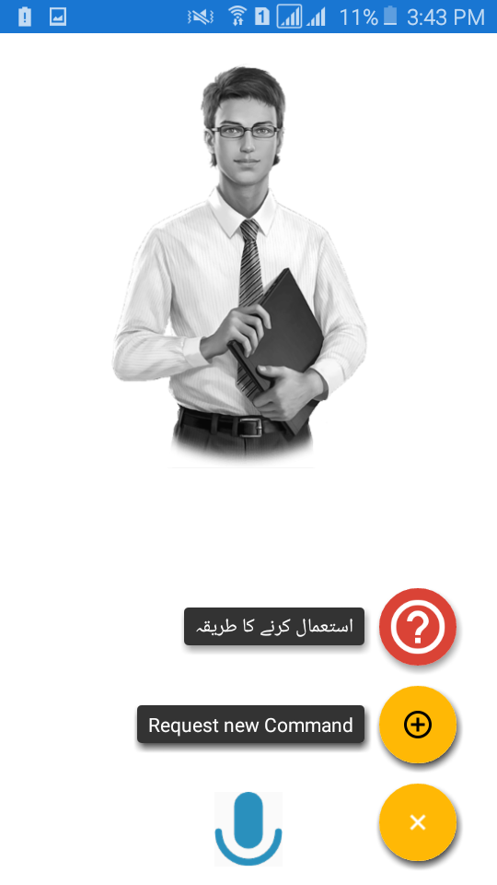

Prototype 1: (P1) Main Screen (input command screen)

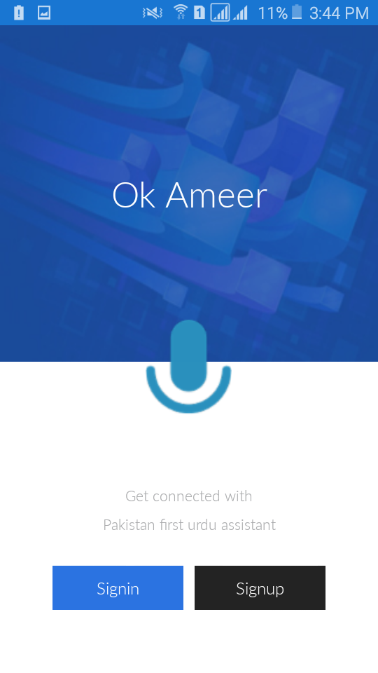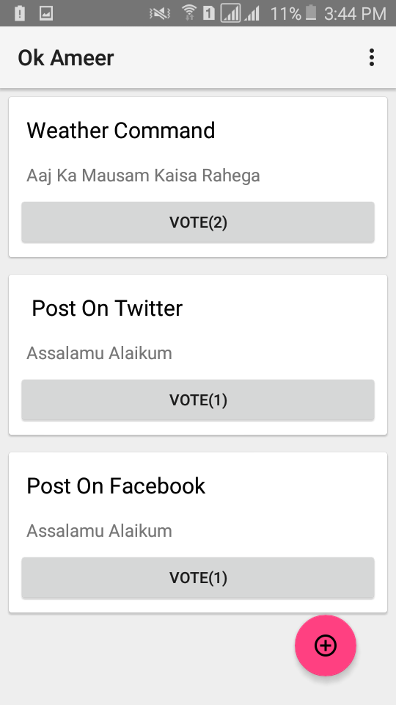

Figure : prototype 1

# Data flow diagram (optional)

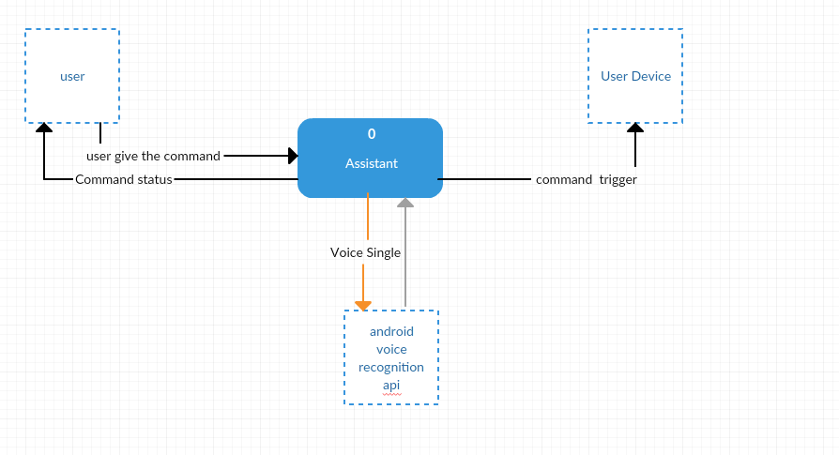

Figure : DFD level 0

# System Design

## System Architecture Diagram

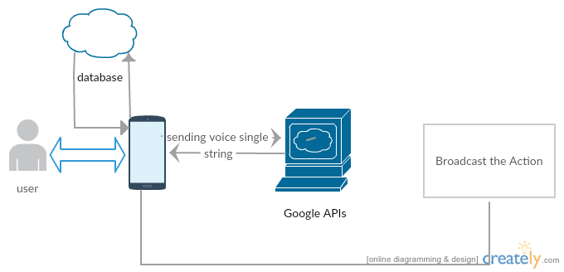

Figure : system Architecture Diagram

## Class Diagram



Figure : Class Diagram

## Sequence Diagrams

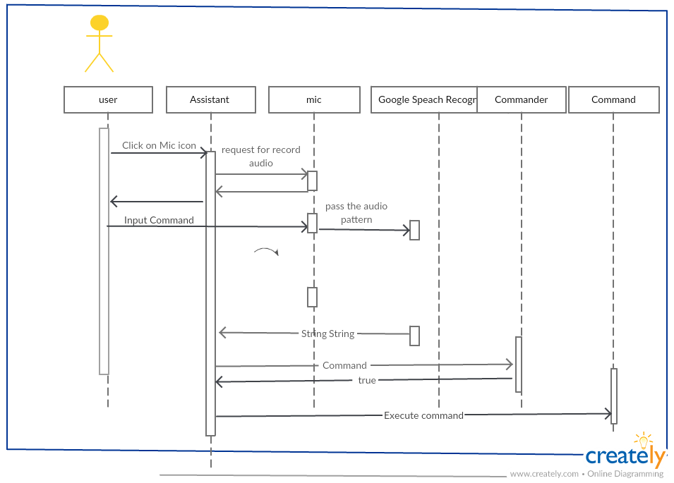

Figure : Sequence Diagrams

## Collaboration Diagrams

## ERD

I am using the NoSQl database to store data, data store in JSON formate so there is no concepet of table, relation ship etc, that’s make imposible to creat the Entity relationship digram for this project bellow give figure is json data representation:

{

"UserRequstedCommands" : {

"ali1atThegmailDotcom" : {

"Weather Command" : {

"CommandDetail" : {

"commandAction" : "Aaj Ka Mausam Kaisa Rahega",

"commandName" : "Weather Command",

"commandRequstedby" : "ali1@gmail.com"

},

"VotedBy" : {

"ali1atThegmailDotcom" : "ali1@gmail.com",

"aliatThegmailDotcom" : "ali@gmail.com"

}

}

},

"aliatThegmailDotcom" : {

"Post On Facebook" : {

"CommandDetail" : {

"commandAction" : "Assalamu Alaikum",

"commandName" : "Post On Facebook",

"commandRequstedby" : "ali@gmail.com"

},

"VotedBy" : {

"aliatThegmailDotcom" : "ali@gmail.com"

}

}

}

}

}

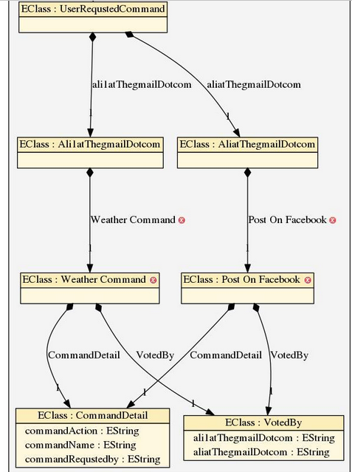

Figure : EDR

## Data Dictionary

|  |  |  |  |  |
| --- | --- | --- | --- | --- |
| Element Name | Type | Validation | Mandatory | Remarks |
| Command | Voice | voice | Voice |  |
| Login Email | String | char | String with @ |  |
| Login password | String | char | More than 6 char |  |

# Implementation details

## Development Setup

IDE Android studio

Data Base firebase

Languages java, xml, JSON, kotlin

## Deployment setup

This project still in development phase so we not upload the app on Google play store

## Algorithms

This based on command design pattern, Assistant take voice input from user and pass to speech recognizer, speech recognizer give text back and pass to Command Invoker java class that can be loop through from all command and try to find trigger word, in case of command activating phrase match to user given command, command invoker will call execute method of that command,

Reading data from database done by voting class once sync from firebase, voting class have one more class for update UI that is run by other thread

## Constraints

### Assumptions

* All database maintenance will be handled by the Google firebase team.
* Speech recognition handle by Google team

### System constraints

* User device should have running android version 15+
* User device should have TTS Hindi before using this system

### Restrictions

No

### Limitations

Assistant can execute only those command that show in help menu

Assistant can’t work offline at this time

# Testing

## Extended Test Cases

|  |  |  |  |  |  |  |  |
| --- | --- | --- | --- | --- | --- | --- | --- |
| Test Case ID: 1 | | | Test Design By: Hamza rafiq | | | | |
| Test Module Name: flash light | | | Test Design Date: 7/26/2017 | | | | |
| Test Priority: High | | | Test Executed By: sir Muhammad Nabeel | | | | |
| Test Tittle: To test turn on flash light | | | Test Executed Date:7/27/2017 | | | | |
| Description: turn on device flash light with voice command. | | | | | | | |
| Pre-Condition: user give all necessary permissions at run time or install time, user device should connect to internet, user device microphone should not be used by other apps, user should start speaking after here beep, flash light should be turned off already | | | | | | | |
| Dependencies: | | | | | | | |
| Step | Test Step | Test Data | | Expected  Result | Actual  Result | Status | Notes |
| 1 | Open the Assistant |  | | Assistant will be open. | Assistant opened. | Pass |  |
| 2 | Click on mic button from bottom of screen |  | | New screen will be open | New screen successfully opened | pass |  |
| 3 | Wait for Assistant to ready mic for you |  | | Mic will be ready and user here beep sound | Beep | Pass |  |
| 4 | Now start speaking | says “light on, flash light on Karoo, flash light” | | Flash light will turn on and user navigate to flash light activity witch have one button to turn off flash light, and user also see flash light icon in notification panel | Flash light turned on and user Now in flash light activity, and icon appear in notification panel | pass |  |
| Post Condition: | | Flash light turned on and user in new flash light activity with one button to turn it off | | | | | |

|  |  |  |  |  |  |  |  |
| --- | --- | --- | --- | --- | --- | --- | --- |
| Test Case ID: 2 | | | Test Design By: Hamza rafiq | | | | |
| Test Module Name: flash light | | | Test Design Date: 7/26/2017 | | | | |
| Test Priority: High | | | Test Executed By: sir Muhammad Nabeel | | | | |
| Test Tittle: To test turn off flash light | | | Test Executed Date:7/27/2017 | | | | |
| Description: turn on device flash light with voice command. | | | | | | | |
| Pre-Condition: user give all necessary permissions at run time or install time, user device should connect to internet, user device microphone should not be used by other apps, user should start speaking after here beep, flash light should be turned on already using assistant, user should be inside the flash light activity | | | | | | | |
| Dependencies: | | | | | | | |
| Step | Test Step | Test Data | | Expected  Result | Actual  Result | Status | Notes |
| 1 | Click on turn off button from flash light activity |  | | New dialog will be open. | Dialog opened | Pass |  |
| 2 | Wait for Assistant to ready mic for you |  | | Mic will be ready and user here beep sound | Beep | Pass |  |
| 3 | Now start speaking | says “light off, flash light band, light off” | | Flash light will turn off and user navigate to home screen flash light icon disappear from in notification panel | Flash light turned on and user Now home screen and icon disappear from notification panel | pass |  |
| Post Condition: | | Flash light turned off and user in home screen | | | | | |

|  |  |  |  |  |  |  |  |
| --- | --- | --- | --- | --- | --- | --- | --- |
| Test Case ID: 2.1 | | Test Design By: Hamza rafiq | | | | | |
| Test Module Name: flash light | | Test Design Date: 7/26/2017 | | | | | |
| Test Priority: High | | Test Executed By: sir Muhammad Nabeel | | | | | |
| Test Tittle: To test turn off flash light if flash light already off | | Test Executed Date:7/27/2017 | | | | | |
| Description: turn on device flash light with voice command. | | | | | | | |
| Pre-Condition: user give all necessary permissions at run time or install time, user device should connect to internet, user device microphone should not be used by other apps, user should start speaking after here beep, flash light should be turned on already using assistant, user should be on main | | | | | | | |
| Dependencies: | | | | | | | |
| Step | Test Step | | Test Data | Expected  Result | Actual  Result | Status | Notes |
| 1 | Open the Assistant | |  | Assistant will be open. | Assistant opened. | Pass |  |
| 2 | Click on mic button from bottom of screen | |  | New screen will be open | New screen successfully opened | pass |  |
| 3 | Wait for Assistant to ready mic for you | |  | Mic will be ready and user here beep sound | Beep | Pass |  |
| 4 | Now start speaking | | says “light off, flash light band, light off” | Assistant still the request the flash light receiver and flash light remain off | Assistant send the request to flash light receiver and flash light reaming turn off | pass |  |

|  |  |  |  |  |  |  |  |
| --- | --- | --- | --- | --- | --- | --- | --- |
| Test Case ID: 3 | | | Test Design By: Hamza rafiq | | | | |
| Test Module Name: Bluetooth | | | Test Design Date: 7/26/2017 | | | | |
| Test Priority: High | | | Test Executed By: sir Muhammad Nabeel | | | | |
| Test Tittle: To test turn on Bluetooth | | | Test Executed Date:7/27/2017 | | | | |
| Description: turn on device flash light with voice command . | | | | | | | |
| Pre-Condition: user give all necessary permissions at run time or install time, user device should connect to internet, user device microphone should not be used by other apps, user should start speaking after here beep, Bluetooth should be turn off already | | | | | | | |
| Dependencies: | | | | | | | |
| Step | Test Step | Test Data | | Expected  Result | Actual  Result | Status | Notes |
| 1 | Open the Assistant |  | | Assistant will be open. | Assistant opened. | Pass |  |
| 2 | Click on mic button from bottom of screen |  | | New screen will be open | New screen successfully opened | pass |  |
| 3 | Wait for Assistant to ready mic for you |  | | Mic will be ready and user here beep sound | Beep | Pass |  |
| 4 | Now start speaking | says “Bluetooth on Karoo” | | Bluetooth will turn on and user will be stay on home screen | Bluetooth turned on | pass |  |
| Post Condition: | | Bluetooth turned on and user will be stay at home screen | | | | | |

|  |  |  |  |  |  |  |  |
| --- | --- | --- | --- | --- | --- | --- | --- |
| Test Case ID:4 | | | Test Design By: Hamza rafiq | | | | |
| Test Module Name: Bluetooth | | | Test Design Date: 7/26/2017 | | | | |
| Test Priority: High | | | Test Executed By: sir Muhammad Nabeel | | | | |
| Test Tittle: To test turn off Bluetooth | | | Test Executed Date:7/27/2017 | | | | |
| Description: turn off device Bluetooth with voice command . | | | | | | | |
| Pre-Condition: user give all necessary permissions at run time or install time, user device should connect to internet, user device microphone should not be used by other apps, user should start speaking after here beep, Bluetooth should be turn on already | | | | | | | |
| Dependencies: | | | | | | | |
| Step | Test Step | Test Data | | Expected  Result | Actual  Result | Status | Notes |
| 1 | Open the Assistant |  | | Assistant will be open. | Assistant opened. | Pass |  |
| 2 | Click on mic button from bottom of screen |  | | New screen will be open | New screen successfully opened | pass |  |
| 3 | Wait for Assistant to ready mic for you |  | | Mic will be ready and user here beep sound | Beep | Pass |  |
| 4 | Now start speaking | says “Bluetooth off Karoo” | | Bluetooth will turn off and user will be stay on home screen | Bluetooth turned off | pass |  |
| Post Condition: | | Bluetooth turned off and user will be stay at home screen | | | | | |

|  |  |  |  |  |  |  |  |
| --- | --- | --- | --- | --- | --- | --- | --- |
| Test Case ID:5 | | | | Test Design By: Hamza rafiq | | | |
| Test Module Name: music | | | | Test Design Date: 7/26/2017 | | | |
| Test Priority: High | | | | Test Executed By: sir Muhammad Nabeel | | | |
| Test Tittle: To play music from device | | | | Test Executed Date:7/27/2017 | | | |
| Description: play song from device with voice command . | | | | | | | |
| Pre-Condition: user give all necessary permissions at run time or install time, user device should connect to internet, user device microphone should not be used by other apps, user should start speaking after here beep, user should have install default music player install by Google, user should configure android default music app before play song using assistant, user should have more than one audio song in his device | | | | | | | |
| Dependencies: | | | | | | | |
| Step | Test Step | Test Data | Expected  Result | | Actual  Result | Status | Notes |
| 1 | Open the Assistant |  | Assistant will be open. | | Assistant opened. | Pass |  |
| 2 | Click on mic button from bottom of screen |  | New screen will be open | | New screen successfully opened | pass |  |
| 3 | Wait for Assistant to ready mic for you |  | Mic will be ready and user here beep sound | | Beep | Pass |  |
| 4 | Now start speaking | says “gana lagao ” | Assistant will open Google music app and play first song | | Assistant Open the Google music app, and first song begin to play | Pass |  |
| Post Condition: | | Google default music app will be open and first song will be played | | | | | |

|  |  |  |  |  |  |  |
| --- | --- | --- | --- | --- | --- | --- |
| Test Case ID:6 | | | Test Design By: Hamza rafiq | | | |
| Test Module Name: music | | | Test Design Date: 7/26/2017 | | | |
| Test Priority: High | | | Test Executed By: sir Muhammad Nabeel | | | |
| Test Tittle: To play music from device if there is no song | | | Test Executed Date:7/27/2017 | | | |
| Description: play song from device with voice command . | | | | | | |
| Pre-Condition: user give all necessary permissions at run time or install time, user device should connect to internet, user device microphone should not be used by other apps, user should start speaking after here beep, user should have install default music player install by Google, user should configure Google music app before play song using assistant, | | | | | | |
| Dependencies: | | | | | | |
| Step | Test Step | Test Data | Expected  Result | Actual  Result | Status | Notes |
| 1 | Open the Assistant |  | Assistant will be open. | Assistant opened. | Pass |  |
| 2 | Click on mic button from bottom of screen |  | New screen will be open | New screen successfully opened | pass |  |
| 3 | Wait for Assistant to ready mic for you |  | Mic will be ready and user here beep sound | Beep | Pass |  |
| 4 | Now start speaking | says “gana lagao ” | Assistant will open Google music app and try to play song | Assistant Open the Google music app, can’t able to play song | fail |  |
| Post Condition: | | Google default music app will be open can’t able to play any song | | | | |

|  |  |  |  |  |  |  |  |
| --- | --- | --- | --- | --- | --- | --- | --- |
| Test Case ID:7 | | | Test Design By: Hamza rafiq | | | | |
| Test Module Name: music | | | Test Design Date: 7/26/2017 | | | | |
| Test Priority: High | | | Test Executed By: sir Muhammad Nabeel | | | | |
| Test Tittle: To play music from device if user not configure android default music app | | | Test Executed Date:7/27/2017 | | | | |
| Description: play song from device with voice command. if user not configure the android default music app | | | | | | | |
| Pre-Condition: user give all necessary permissions at run time or install time, user device should connect to internet, user device microphone should not be used by other apps, user should start speaking after here beep, user should have install default music player install by Google, user should have more the 1 audio song in his device | | | | | | | |
| Dependencies: | | | | | | | |
| Step | Test Step | Test Data | | Expected  Result | Actual  Result | Status | Notes |
| 1 | Open the Assistant |  | | Assistant will be open. | Assistant opened. | Pass |  |
| 2 | Click on mic button from bottom of screen |  | | New screen will be open | New screen successfully opened | pass |  |
| 3 | Wait for Assistant to ready mic for you |  | | Mic will be ready and user here beep sound | Beep | Pass |  |
| 4 | Now start speaking | says “gana lagao ” | | Assistant will open android default music app ask to user configure app only first time | Assistant Open the Google music app, and ask user to configure the app | pass |  |
| Post Condition: | | Android default music app will be open ask to user to configer the app for first time | | | | | |

|  |  |  |  |  |  |  |  |
| --- | --- | --- | --- | --- | --- | --- | --- |
| Test Case ID:8 | | | Test Design By: Hamza rafiq | | | | |
| Test Module Name: music | | | Test Design Date: 7/26/2017 | | | | |
| Test Priority: High | | | Test Executed By: sir Muhammad Nabeel | | | | |
| Test Tittle: play next song | | | Test Executed Date:7/27/2017 | | | | |
| Description: play song from device with voice command . | | | | | | | |
| Pre-Condition: user give all necessary permissions at run time or install time, user device should connect to internet, user device microphone should not be used by other apps, user should start speaking after here beep, user should have install default music player install by Google, user should configure Google music app before play song using assistant, user should have more than one audio song in his device , audio music should be playing in background from com.android.music.musicservicecommand package | | | | | | | |
| Dependencies: | | | | | | | |
| Step | Test Step | Test Data | | Expected  Result | Actual  Result | Status | Notes |
| 1 | Open the Assistant |  | | Assistant will be open. | Assistant opened. | Pass |  |
| 2 | Click on mic button from bottom of screen |  | | New screen will be open | New screen successfully opened | pass |  |
| 3 | Wait for Assistant to ready mic for you |  | | Mic will be ready and user here beep sound | Beep | Pass |  |
| 4 | Now start speaking | says “agala gaana ” | | Assistant will send broad cast to com.android.music.musicservicecommand and next audio song will be played | Assistant successfully played next song | pass |  |
| Post Condition: | | Next audio song will be played | | | | | |

|  |  |  |  |  |  |  |  |
| --- | --- | --- | --- | --- | --- | --- | --- |
| Test Case ID:8 | | | Test Design By: Hamza rafiq | | | | |
| Test Module Name: music | | | Test Design Date: 7/26/2017 | | | | |
| Test Priority: High | | | Test Executed By: sir Muhammad Nabeel | | | | |
| Test Tittle: play next song if current song is last song | | | Test Executed Date:7/27/2017 | | | | |
| Description: play song from device with voice command . if currently playing song is last song | | | | | | | |
| Pre-Condition: user give all necessary permissions at run time or install time, user device should connect to internet, user device microphone should not be used by other apps, user should start speaking after here beep, user should have install default music player install by Google, user should configure Google music app before play song using assistant, user should have more than one audio song in his device , audio music should be playing in background from com.android.music.musicservicecommand package | | | | | | | |
| Dependencies: | | | | | | | |
| Step | Test Step | Test Data | | Expected  Result | Actual  Result | Status | Notes |
| 1 | Open the Assistant |  | | Assistant will be open. | Assistant opened. | Pass |  |
| 2 | Click on mic button from bottom of screen |  | | New screen will be open | New screen successfully opened | pass |  |
| 3 | Wait for Assistant to ready mic for you |  | | Mic will be ready and user here beep sound | Beep | Pass |  |
| 4 | Now start speaking | says “agala gaana ” | | Assistant will send broad cast to com.android.music.musicservicecommand and first song will be played | Assistant successfully played first song from beginning of playlist | pass |  |
| Post Condition: | | First audio song will be played | | | | | |

|  |  |  |  |  |  |  |  |
| --- | --- | --- | --- | --- | --- | --- | --- |
| Test Case ID:9 | | | Test Design By: Hamza rafiq | | | | |
| Test Module Name: music | | | Test Design Date: 7/26/2017 | | | | |
| Test Priority: High | | | Test Executed By: sir Muhammad Nabeel | | | | |
| Test Tittle: stop music | | | Test Executed Date:7/27/2017 | | | | |
| Description: stop song from device with voice command. | | | | | | | |
| Pre-Condition: user give all necessary permissions at run time or install time, user device should connect to internet, user device microphone should not be used by other apps, user should start speaking after here beep, user should have install default music player install by Google, user should configure Google music app before play song using assistant, user should have more than one audio song in his device , audio music should be playing in background from com.android.music.musicservicecommand package | | | | | | | |
| Dependencies: | | | | | | | |
| Step | Test Step | Test Data | | Expected  Result | Actual  Result | Status | Notes |
| 1 | Open the Assistant |  | | Assistant will be open. | Assistant opened. | Pass |  |
| 2 | Click on mic button from bottom of screen |  | | New screen will be open | New screen successfully opened | pass |  |
| 3 | Wait for Assistant to ready mic for you |  | | Mic will be ready and user here beep sound | Beep | Pass |  |
| 4 | Now start speaking | says “gaana band karo” | | Assistant will send broad cast to com.android.music.musicservicecommand and music will be played | Assistant successfully stop music | pass |  |
| Post Condition: | | Assistant stop music and user now can see media player state in notification panel | | | | | |

|  |  |  |  |  |  |  |  |
| --- | --- | --- | --- | --- | --- | --- | --- |
| Test Case ID:10 | | | Test Design By: Hamza rafiq | | | | |
| Test Module Name: music | | | Test Design Date: 7/26/2017 | | | | |
| Test Priority: High | | | Test Executed By: sir Muhammad Nabeel | | | | |
| Test Tittle: stop music | | | Test Executed Date:7/27/2017 | | | | |
| Description: stop music when music not playing in back ground | | | | | | | |
| Pre-Condition: user give all necessary permissions at run time or install time, user device should connect to internet, user device microphone should not be used by other apps, user should start speaking after here beep, user should have install default music player install by Google, user should configure Google music app before play song using assistant, user should have more than one audio song in his device | | | | | | | |
| Dependencies: | | | | | | | |
| Step | Test Step | Test Data | | Expected  Result | Actual  Result | Status | Notes |
| 1 | Open the Assistant |  | | Assistant will be open. | Assistant opened. | Pass |  |
| 2 | Click on mic button from bottom of screen |  | | New screen will be open | New screen successfully opened | pass |  |
| 3 | Wait for Assistant to ready mic for you |  | | Mic will be ready and user here beep sound | Beep | Pass |  |
| 4 | Now start speaking | says “gaana band karo” | | Assistant will send broad cast to com.android.music.musicservicecommand and return to main screen | Assistant stayed on home screen | pass |  |
| Post Condition: | | Assistant will remain on home screen | | | | | |

|  |  |  |  |  |  |  |  |
| --- | --- | --- | --- | --- | --- | --- | --- |
| Test Case ID:11 | | | Test Design By: Hamza rafiq | | | | |
| Test Module Name: music | | | Test Design Date: 7/26/2017 | | | | |
| Test Priority: High | | | Test Executed By: sir Muhammad Nabeel | | | | |
| Test Tittle: paly song from YouTube | | | Test Executed Date:7/27/2017 | | | | |
| Description: play song from YouTube | | | | | | | |
| Pre-Condition: user give all necessary permissions at run time or install time, user device should connect to internet, user device microphone should not be used by other apps, user should start speaking after here beep, user should have install latest YouTube app | | | | | | | |
| Dependencies: | | | | | | | |
| Step | Test Step | Test Data | | Expected  Result | Actual  Result | Status | Notes |
| 1 | Open the Assistant |  | | Assistant will be open. | Assistant opened. | Pass |  |
| 2 | Click on mic button from bottom of screen |  | | New screen will be open | New screen successfully opened | pass |  |
| 3 | Wait for Assistant to ready mic for you |  | | Mic will be ready and user here beep sound | Beep | Pass |  |
| 4 | Now start speaking | says “YouTube say gana lagao” | | Assistant will verify command and ask for song name | Assistant ask for song name | pass |  |
| 5 | Wait for assistant prompt the voice recognition dialog | Say just song name “Chammak challo” | | Assistant will Query to YouTube data API and get back response, and play first song from response | Song now played in full screen | pass |  |
| Post Condition: | | Assistant will play song in full, user no longer control over assistant using voice | | | | | |

|  |  |  |  |  |  |  |  |
| --- | --- | --- | --- | --- | --- | --- | --- |
| Test Case ID:9 | | | Test Design By: Hamza rafiq | | | | |
| Test Module Name: Message | | | Test Design Date: 7/26/2017 | | | | |
| Test Priority: High | | | Test Executed By: sir Muhammad Nabeel | | | | |
| Test Tittle: write message using voice and send it automatically | | | Test Executed Date:7/27/2017 | | | | |
| Description: send text message using voice to saved phone contacts | | | | | | | |
| Pre-Condition: user give all necessary permissions at run time or install time, user device should connect to internet, user device microphone should not be used by other apps, user should start speaking after here beep, user should save target number before try to send message, | | | | | | | |
| Dependencies: | | | | | | | |
| Step | Test Step | Test Data | | Expected  Result | Actual  Result | Status | Notes |
| 1 | Open the Assistant |  | | Assistant will be open. | Assistant opened. | Pass |  |
| 2 | Click on mic button from bottom of screen |  | | New screen will be open | New screen successfully opened | pass |  |
| 3 | Wait for Assistant to ready mic for you |  | | Mic will be ready and user here beep sound | Beep | Pass |  |
| 4 | Now start speaking | says “message liko ” | | Assistant will verify command and ask for recipient name | Assistant asked for number | pass |  |
| 6 | Wait for assistant prompt the voice recognition dialog | Say recipient name e.g. “sir nabeel” | | Assistant will Query to android contact provide class and update the UI if name found in user contact list | Assistant updated the UI with recipient name | pass |  |
| 7 | Wait for assistant prompt the voice recognition dialog | now please write you message eg “Assalamu alaikum sir ksaie hai” | | Assistant take vice input from user and update the UI along with text, and take 3 to send text message | Assistant send text message after 3s | pass |  |
| Post Condition: | | After sending text user navigate to home page | | | | | |

|  |  |  |  |  |  |  |  |
| --- | --- | --- | --- | --- | --- | --- | --- |
| Test Case ID:12 | | | Test Design By: Hamza rafiq | | | | |
| Test Module Name: Message | | | Test Design Date: 7/26/2017 | | | | |
| Test Priority: High | | | Test Executed By: sir Muhammad Nabeel | | | | |
| Test Tittle: write message using voice and try to send unknown number | | | Test Executed Date:7/27/2017 | | | | |
| Description: send text message using voice to unknown contact | | | | | | | |
| Pre-Condition: user give all necessary permissions at run time or install time, user device should connect to internet, user device microphone should not be used by other apps, user should start speaking after here beep | | | | | | | |
| Dependencies: | | | | | | | |
| Step | Test Step | Test Data | | Expected  Result | Actual  Result | Status | Notes |
| 1 | Open the Assistant |  | | Assistant will be open. | Assistant opened. | Pass |  |
| 2 | Click on mic button from bottom of screen |  | | New screen will be open | New screen successfully opened | pass |  |
| 3 | Wait for Assistant to ready mic for you |  | | Mic will be ready and user here beep sound | Beep | Pass |  |
| 4 | Now start speaking | says “message liko ” | | Assistant will verify command and ask for recipient name | Assistant asked for number | pass |  |
| 6 | Wait for assistant prompt the voice recognition dialog | Say recipient name eg “unknown name” | | Assistant will Query to android contact provide class and ask for correct name | Assistant asked for correct name | pass |  |
| Post Condition: | | Assistant will keep asking the correct recipient name | | | | | |

|  |  |  |  |  |  |  |  |
| --- | --- | --- | --- | --- | --- | --- | --- |
| Test Case ID:13 | | | Test Design By: Hamza rafiq | | | | |
| Test Module Name: Message | | | Test Design Date: 7/26/2017 | | | | |
| Test Priority: High | | | Test Executed By: sir Muhammad Nabeel | | | | |
| Test Tittle: write message using voice and send it automatically | | | Test Executed Date:7/27/2017 | | | | |
| Description: send a empty text message | | | | | | | |
| Pre-Condition: user give all necessary permissions at run time or install time, user device should connect to internet, user device microphone should not be used by other apps, user should start speaking after here beep, user should have saved recipient contact name before send | | | | | | | |
| Dependencies: | | | | | | | |
| Step | Test Step | Test Data | | Expected  Result | Actual  Result | Status | Notes |
| 1 | Open the Assistant |  | | Assistant will be open. | Assistant opened. | Pass |  |
| 2 | Click on mic button from bottom of screen |  | | New screen will be open | New screen successfully opened | pass |  |
| 3 | Wait for Assistant to ready mic for you |  | | Mic will be ready and user here beep sound | Beep | Pass |  |
| 4 | Now start speaking | says “message liko ” | | Assistant will verify command and ask for recipient name | Assistant asked for number | pass |  |
| 6 | Wait for assistant prompt the voice recognition dialog | Say recipient name e.g. “Irfan” | | Assistant will Query to android contact provide class and update the UI with founded contact name | Assistant update the UI with name | pass |  |
| 6 | Wait for assistant prompt the voice recognition dialog for text message | Say nothing | | Assistant will wait few second if there is no voice input from user side assistant will return to message UI | Assistant return to message activity | pass |  |
| Post Condition: | | Assistant will not send text message and return to message screen | | | | | |

|  |  |  |  |  |  |  |  |
| --- | --- | --- | --- | --- | --- | --- | --- |
| Test Case ID:14 | | | Test Design By: Hamza rafiq | | | | |
| Test Module Name: Message | | | Test Design Date: 7/26/2017 | | | | |
| Test Priority: High | | | Test Executed By: sir Muhammad Nabeel | | | | |
| Test Tittle: test mic button from message screen | | | Test Executed Date:7/27/2017 | | | | |
| Description: try to test to mic button from message in case of user can’t able write a message in first place | | | | | | | |
| Pre-Condition: user give all necessary permissions at run time or install time, user device should connect to internet, user device microphone should not be used by other apps, user should start speaking after here beep, user should have saved recipient contact name before send | | | | | | | |
| Dependencies: | | | | | | | |
| Step | Test Step | Test Data | | Expected  Result | Actual  Result | Status | Notes |
| 1 | Open the Assistant |  | | Assistant will be open. | Assistant opened. | Pass |  |
| 2 | Click on mic button from bottom of screen |  | | New screen will be open | New screen successfully opened | pass |  |
| 3 | Wait for Assistant to ready mic for you |  | | Mic will be ready and user here beep sound | Beep | Pass |  |
| 4 | Now start speaking | says “message liko ” | | Assistant will verify command and ask for recipient name | Assistant asked for number | pass |  |
| 6 | Wait for assistant prompt the voice recognition dialog | Say recipient name e.g. “Irfan” | | Assistant will Query to android contact provide class and update the UI with founded contact name | Assistant update the UI with name | pass |  |
| 6 | Wait for assistant prompt the voice recognition dialog for text message | Say nothing | | Assistant will wait few second if there is no voice input from user side assistant will return to message UI | Assistant return to message activity | pass |  |
| 7 | Click on mic button inside the message UI |  | | Assistant will show dialog to user to retry write a message | Assistant showed the dialog to user to retry write text message | pass |  |
| 8 |  |  | | Assistant will verify the text message is text empty or not and send it incase not empty | Assistant send the text message | pass |  |
| Post Condition: | | Assistant will send text message and return to home screen | | | | | |

|  |  |  |  |  |  |  |  |
| --- | --- | --- | --- | --- | --- | --- | --- |
| Test Case ID:15 | | | Test Design By: Hamza rafiq | | | | |
| Test Module Name: send message button | | | Test Design Date: 7/26/2017 | | | | |
| Test Priority: medium | | | Test Executed By: sir Muhammad Nabeel | | | | |
| Test Tittle: test send button from message screen | | | Test Executed Date:7/27/2017 | | | | |
| Description: each message take 3 second before send but user can send message without wait for 3s to complete using send button inside the message screen | | | | | | | |
| Pre-Condition: user give all necessary permissions at run time or install time, user device should connect to internet, user device microphone should not be used by other apps, user should start speaking after here beep, Assistant should recipient name and text message | | | | | | | |
| Dependencies: | | | | | | | |
| Step | Test Step | Test Data | | Expected  Result | Actual  Result | Status | Notes |
| 1 | Open the Assistant |  | | Assistant will be open. | Assistant opened. | Pass |  |
| 2 | Click on mic button from bottom of screen |  | | New screen will be open | New screen successfully opened | pass |  |
| 3 | Wait for Assistant to ready mic for you |  | | Mic will be ready and user here beep sound | Beep | Pass |  |
| 4 | Now start speaking | says “message liko ” | | Assistant will verify command and ask for recipient name | Assistant asked for number | pass |  |
| 6 | Wait for assistant prompt the voice recognition dialog | Say recipient name e.g. “Irfan” | | Assistant will Query to android contact provide class and update the UI with founded contact name | Assistant update the UI with name | pass |  |
| 6 | Wait for assistant prompt the voice recognition dialog | Speak your text message | | Assistant will update the UI with text message | Assistant update the UI | pass |  |
| 8 | Assistant start count down for 3s | Press the send button | | Assistant will send the text message | Assistant send the text message | pass |  |
| Post Condition: | | Assistant will send text message and return to home screen | | | | | |

|  |  |  |  |  |  |  |  |
| --- | --- | --- | --- | --- | --- | --- | --- |
| Test Case ID:16 | | | Test Design By: Hamza rafiq | | | | |
| Test Module Name: Message | | | Test Design Date: 7/26/2017 | | | | |
| Test Priority: High | | | Test Executed By: sir Muhammad Nabeel | | | | |
| Test Tittle: write what’s app message using voice | | | Test Executed Date:7/27/2017 | | | | |
| Description: send text message using voice to saved phone contacts | | | | | | | |
| Pre-Condition: user give all necessary permissions at run time or install time, user device should connect to internet, user device microphone should not be used by other apps, user should start speaking after here beep, user should save target number before try to send message, user should have install what’s app install in his device | | | | | | | |
| Dependencies: | | | | | | | |
| Step | Test Step | Test Data | | Expected  Result | Actual  Result | Status | Notes |
| 1 | Open the Assistant |  | | Assistant will be open. | Assistant opened. | Pass |  |
| 2 | Click on mic button from bottom of screen |  | | New screen will be open | New screen successfully opened | pass |  |
| 3 | Wait for Assistant to ready mic for you |  | | Mic will be ready and user here beep sound | Beep | Pass |  |
| 4 | Now start speaking | says “What’s App send KARO ” | | Assistant will verify command and ask for recipient name | Assistant asked for number | pass |  |
| 6 | Wait for assistant prompt the voice recognition dialog | Say recipient name e.g. “sir Nabeel” | | Assistant will Query to android contact provide class and update the UI if name found in user contact list | Assistant updated the UI with recipient name | pass |  |
| 7 | Wait for assistant prompt the voice recognition dialog | now please write you message e.g. “assalam o alaikum” | | Assistant take vice input from user and open the what’s app so user can verify the message and then press to send | Assistant open the what’s app after 3s | pass |  |
| Post Condition: | | User will be inside the what’s app | | | | | |

|  |  |  |  |  |  |  |  |
| --- | --- | --- | --- | --- | --- | --- | --- |
| Test Case ID:17 | | | Test Design By: Hamza rafiq | | | | |
| Test Module Name: Email | | | Test Design Date: 7/26/2017 | | | | |
| Test Priority: High | | | Test Executed By: sir Muhammad Nabeel | | | | |
| Test Tittle: write Gmail using voice | | | Test Executed Date:7/27/2017 | | | | |
| Description: send text message using voice to saved phone contacts | | | | | | | |
| Pre-Condition: user give all necessary permissions at run time or install time, user device should connect to internet, user device microphone should not be used by other apps, user should start speaking after here beep, user should save recipient Email address inside the phone contact before try to send message, user should have install Gmail app install in his device | | | | | | | |
| Dependencies: | | | | | | | |
| Step | Test Step | Test Data | | Expected  Result | Actual  Result | Status | Notes |
| 1 | Open the Assistant |  | | Assistant will be open. | Assistant opened. | Pass |  |
| 2 | Click on mic button from bottom of screen |  | | New screen will be open | New screen successfully opened | pass |  |
| 3 | Wait for Assistant to ready mic for you |  | | Mic will be ready and user here beep sound | Beep | Pass |  |
| 4 | Now start speaking | says “What’s App send karo ” | | Assistant will verify command and ask for recipient name | Assistant asked for number | pass |  |
| 6 | Wait for assistant prompt the voice recognition dialog | Say recipient name eg “sir nabeel” | | Assistant will Query to android contact provide class and update the UI if name found in user contact list | Assistant updated the UI with recipient name | pass |  |
| 7 | Wait for assistant prompt the voice recognition dialog | now please write you message eg “Assalamu alaikum sir ksaie hai” | | Assistant take vice input from user and open the what’s app so user can verify the message and then press to send | Assistant open the what’s app after 3s | pass |  |
| Post Condition: | | User will be inside the what’s app | | | | | |

|  |  |  |  |  |  |  |  |
| --- | --- | --- | --- | --- | --- | --- | --- |
| Test Case ID:18 | | Test Design By: Hamza rafiq | | | | | |
| Test Module Name: message | | Test Design Date: 7/26/2017 | | | | | |
| Test Priority: High | | Test Executed By: sir Muhammad Nabeel | | | | | |
| Test Tittle: test read message (Roman urdu) | | Test Executed Date:7/27/2017 | | | | | |
| Description: send text message using voice to saved phone contacts | | | | | | | |
| Pre-Condition: user give all necessary permissions at run time or install time, user device should connect to internet, user device microphone should not be used by other apps, user should start speaking after here beep, user should have more than 1 unread message, user should have only roman text message for read | | | | | | | |
| Dependencies: | | | | | | | |
| Step | Test Step | | Test Data | Expected  Result | Actual  Result | Status | Notes |
| 1 | Open the Assistant | |  | Assistant will be open. | Assistant opened. | Pass |  |
| 2 | Click on mic button from bottom of screen | |  | New screen will be open | New screen successfully opened | pass |  |
| 3 | Wait for Assistant to ready mic for you | |  | Mic will be ready and user here beep sound | Beep | Pass |  |
| 4 | Now start speaking | | says “message parho ” | Assistant will verify command and show unread text message to user | Assistant updated the UI with unread text message | pass |  |
| 6 | Wait for assistant prompt the voice recognition dialog | | Says “g ha ” | Assistant will start reading the message | Assistant start reading the unread message | pass |  |
| Post Condition: | | | User can see the unread message list | | | | |

|  |  |  |  |  |  |  |  |
| --- | --- | --- | --- | --- | --- | --- | --- |
| Test Case ID:19 | | Test Design By: Hamza rafiq | | | | | |
| Test Module Name: message | | Test Design Date: 7/26/2017 | | | | | |
| Test Priority: High | | Test Executed By: sir Muhammad Nabeel | | | | | |
| Test Tittle: test skip unread message | | Test Executed Date:7/27/2017 | | | | | |
| Description: send text message using voice to saved phone contacts | | | | | | | |
| Pre-Condition: user give all necessary permissions at run time or install time, user device should connect to internet, user device microphone should not be used by other apps, user should start speaking after here beep, user should have more than 1 unread message, | | | | | | | |
| Dependencies: | | | | | | | |
| Step | Test Step | | Test Data | Expected  Result | Actual  Result | Status | Notes |
| 1 | Open the Assistant | |  | Assistant will be open. | Assistant opened. | Pass |  |
| 2 | Click on mic button from bottom of screen | |  | New screen will be open | New screen successfully opened | pass |  |
| 3 | Wait for Assistant to ready mic for you | |  | Mic will be ready and user here beep sound | Beep | Pass |  |
| 4 | Now start speaking | | says “message parho ” | Assistant will verify command and show unread text message to user | Assistant updated the UI with unread text message | pass |  |
| 6 | Wait for assistant prompt the voice recognition dialog | | Says “nahi ” | Assistant will skip the current message and move to next message | Assistant skipped current message and move to the next message | pass |  |
| Post Condition: | | | User can now move to next mesage | | | | |

|  |  |  |  |  |  |  |  |
| --- | --- | --- | --- | --- | --- | --- | --- |
| Test Case ID:20 | | Test Design By: Hamza rafiq | | | | | |
| Test Module Name: message | | Test Design Date: 7/26/2017 | | | | | |
| Test Priority: High | | Test Executed By: sir Muhammad Nabeel | | | | | |
| Test Tittle: test increase the device ring volume | | Test Executed Date:7/27/2017 | | | | | |
| Description: Increase the user device volume | | | | | | | |
| Pre-Condition: user give all necessary permissions at run time or install time, user device should connect to internet, user device microphone should not be used by other apps, user should start speaking after here beep, user device can’t be at mix level of volume when he/she want to incase the volume , | | | | | | | |
| Dependencies: | | | | | | | |
| Step | Test Step | | Test Data | Expected  Result | Actual  Result | Status | Notes |
| 1 | Open the Assistant | |  | Assistant will be open. | Assistant opened. | Pass |  |
| 2 | Click on mic button from bottom of screen | |  | New screen will be open | New screen successfully opened | pass |  |
| 3 | Wait for Assistant to ready mic for you | |  | Mic will be ready and user here beep sound | Beep | Pass |  |
| 4 | Now start speaking | | says “volume zatada karo ” | Assistant will verify command and show volume bar | Assistant increase the volume and show volume bar on screen | pass |  |
| Post Condition: | | | User can see the volume bar increasing and stay on home screen | | | | |

|  |  |  |  |  |  |  |  |
| --- | --- | --- | --- | --- | --- | --- | --- |
| Test Case ID:21 | | Test Design By: Hamza rafiq | | | | | |
| Test Module Name: message | | Test Design Date: 7/26/2017 | | | | | |
| Test Priority: High | | Test Executed By: sir Muhammad Nabeel | | | | | |
| Test Tittle: test decrease the device ring volume | | Test Executed Date:7/27/2017 | | | | | |
| Description: Increase the user device volume | | | | | | | |
| Pre-Condition: user give all necessary permissions at run time or install time, user device should connect to internet, user device microphone should not be used by other apps, user should start speaking after here beep, user device can’t be at lower level of volume when he/she want to decrease the volume , | | | | | | | |
| Dependencies: | | | | | | | |
| Step | Test Step | | Test Data | Expected  Result | Actual  Result | Status | Notes |
| 1 | Open the Assistant | |  | Assistant will be open. | Assistant opened. | Pass |  |
| 2 | Click on mic button from bottom of screen | |  | New screen will be open | New screen successfully opened | pass |  |
| 3 | Wait for Assistant to ready mic for you | |  | Mic will be ready and user here beep sound | Beep | Pass |  |
| 4 | Now start speaking | | says “volume kam karo ” | Assistant will verify command and show volume bar | Assistant decrease the volume and show volume bar on screen | pass |  |
| Post Condition: | | | User can see the volume bar decreasing the volume and stay on home screen | | | | |

|  |  |  |  |  |  |  |  |
| --- | --- | --- | --- | --- | --- | --- | --- |
| Test Case ID:22 | | Test Design By: Hamza rafiq | | | | | |
| Test Module Name: message | | Test Design Date: 7/26/2017 | | | | | |
| Test Priority: High | | Test Executed By: sir Muhammad Nabeel | | | | | |
| Test Tittle: test decrease the device ring volume | | Test Executed Date:7/27/2017 | | | | | |
| Description: Increase the user device volume | | | | | | | |
| Pre-Condition: user give all necessary permissions at run time or install time, user device should connect to internet, user device microphone should not be used by other apps, user should start speaking after here beep, user device can’t be at lower level of volume when he/she want to decrease the volume , | | | | | | | |
| Dependencies: | | | | | | | |
| Step | Test Step | | Test Data | Expected  Result | Actual  Result | Status | Notes |
| 1 | Open the Assistant | |  | Assistant will be open. | Assistant opened. | Pass |  |
| 2 | Click on mic button from bottom of screen | |  | New screen will be open | New screen successfully opened | pass |  |
| 3 | Wait for Assistant to ready mic for you | |  | Mic will be ready and user here beep sound | Beep | Pass |  |
| 4 | Now start speaking | | says “volume kam karo ” | Assistant will verify command and show volume bar | Assistant decrease the volume and show volume bar on screen | pass |  |
| Post Condition: | | | User can see the volume bar decreasing the volume and stay on home screen | | | | |

|  |  |  |  |  |  |  |  |
| --- | --- | --- | --- | --- | --- | --- | --- |
| Test Case ID:23 | | Test Design By: Hamza rafiq | | | | | |
| Test Module Name: message | | Test Design Date: 7/26/2017 | | | | | |
| Test Priority: High | | Test Executed By: sir Muhammad Nabeel | | | | | |
| Test Tittle: make phone call | | Test Executed Date:7/27/2017 | | | | | |
| Description: user can make phone call to saved numbers | | | | | | | |
| Pre-Condition: user give all necessary permissions at run time or install time, user device should connect to internet, user device microphone should not be used by other apps, user should start speaking after here beep, | | | | | | | |
| Dependencies: | | | | | | | |
| Step | Test Step | | Test Data | Expected  Result | Actual  Result | Status | Notes |
| 1 | Open the Assistant | |  | Assistant will be open. | Assistant opened. | Pass |  |
| 2 | Click on mic button from bottom of screen | |  | New screen will be open | New screen successfully opened | pass |  |
| 3 | Wait for Assistant to ready mic for you | |  | Mic will be ready and user here beep sound | Beep | Pass |  |
| 4 | Now start speaking | | says “call karo ” | Assistant will verify command and for recipient number | Assistant ask for name of recipient | pass |  |
| 5 | Wait for assistant to show dialog | | Say name e.g. Irfan” | Assistant will try to find the name from user phone contact list and update the UI | Assistant update the UI | Pass |  |
| 6 |  | |  | Assistant will make call after 3s, and user will be on calling screen | Assistant start calling to Irfan and update the UI |  |  |
| Post Condition: | | | Assistant will start calling to number and update the UI | | | | |

|  |  |  |  |  |  |  |  |
| --- | --- | --- | --- | --- | --- | --- | --- |
| Test Case ID:24 | | Test Design By: Hamza rafiq | | | | | |
| Test Module Name: Login | | Test Design Date: 7/26/2017 | | | | | |
| Test Priority: High | | Test Executed By: sir Muhammad Nabeel | | | | | |
| Test Tittle: test login | | Test Executed Date:7/27/2017 | | | | | |
| Description: test login with valid password and valid email | | | | | | | |
| Pre-Condition: user give all necessary permissions at run time or install time, user device should connect to internet, user should have already signup for account on assistant , user should not login already | | | | | | | |
| Dependencies: | | | | | | | |
| Step | Test Step | | Test Data | Expected  Result | Actual  Result | Status | Notes |
| 1 | Open the Assistant | |  | Assistant will be open. | Assistant opened. | Pass |  |
| 2 | Click on plus button from right bottom | |  | Two more button will show up | Yes two button show up one with how to use assistant button and 2nd is requests new command | pass |  |
| 3 | Click on request new command button | |  | This will bring screen for login if user not already login to assistant | Assistant show the new screen with two button login and signup | Pass |  |
| 4 | Now click on login button | |  | Assistant will open new screen with two input text filed and one button | Assistant open new screen with two input text filed one for user email and other for password | pass |  |
| 5 | Enter your account details | | Email : ”ali1@gmail.com”  And password”hamza12! @” | Assistant will verify and email and password and open voting activity | Assistant allow user to login and open voting activity where user can now cats vote on existing commands | Pass |  |
| Post Condition: | | | Assistant will allow user to add new command and vote on command that requested by others users | | | | |

|  |  |  |  |  |  |  |  |
| --- | --- | --- | --- | --- | --- | --- | --- |
| Test Case ID:25 | | Test Design By: Hamza rafiq | | | | | |
| Test Module Name: Login | | Test Design Date: 7/26/2017 | | | | | |
| Test Priority: High | | Test Executed By: sir Muhammad Nabeel | | | | | |
| Test Tittle: test login | | Test Executed Date:7/27/2017 | | | | | |
| Description: test login with valid Email and invalid password | | | | | | | |
| Pre-Condition: user give all necessary permissions at run time or install time, user device should connect to internet, user should have already signup for account on assistant , user should not login already | | | | | | | |
| Dependencies: | | | | | | | |
| Step | Test Step | | Test Data | Expected  Result | Actual  Result | Status | Notes |
| 1 | Open the Assistant | |  | Assistant will be open. | Assistant opened. | Pass |  |
| 2 | Click on plus button from right bottom | |  | Two more button will show up | Yes two button show up one with how to use assistant button and 2nd is requests new command | pass |  |
| 3 | Click on request new command button | |  | This will bring screen for login if user not already login to assistant | Assistant show the new screen with two button login and signup | Pass |  |
| 4 | Now click on login button | |  | Assistant will open new screen with two input text filed and one button | Assistant open new screen with two input text filed one for user email and other for password | pass |  |
| 5 | Enter your account details | | Email : ”ali1@gmail.com”  And password”122222” | Assistant will verify and email and password and open voting activity | Assistant not allow to user to login due to invalid password | fail |  |
| Post Condition: | | | Assistant will allow user to add new command and vote on command that requested by others users | | | | |

## Decision Table

### Code snippet

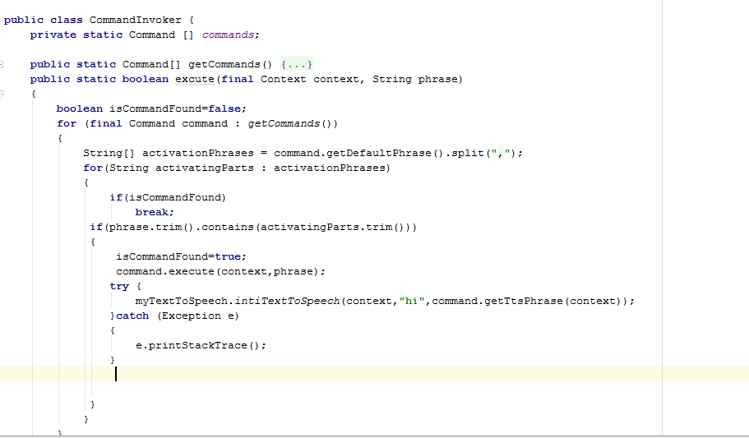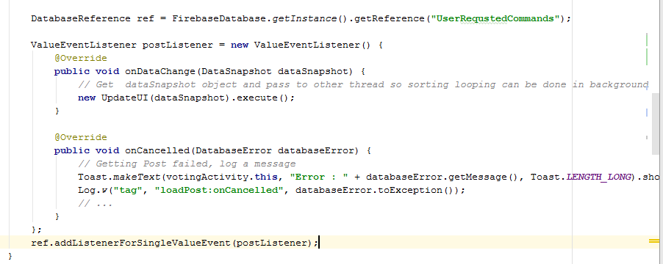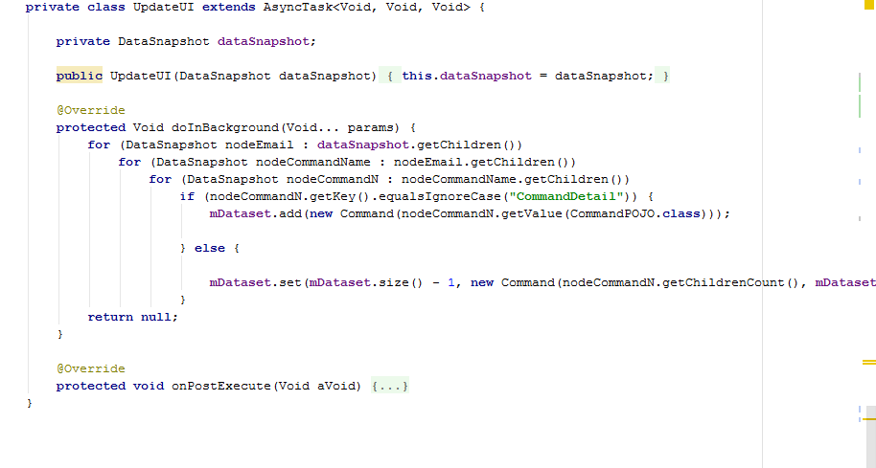

### Decision coverage table

## Traceability Matrix

### RID vs UCID (requirements vs use cases)

|  |  |  |  |  |  |  |  |  |  |  |  |  |  |  |  |  |  |  |  |  |  |  |  |  |  |  |  |  |  |
| --- | --- | --- | --- | --- | --- | --- | --- | --- | --- | --- | --- | --- | --- | --- | --- | --- | --- | --- | --- | --- | --- | --- | --- | --- | --- | --- | --- | --- | --- |
| **UCID/RID** | **R**  **1** | **R**  **2** | **R**  **3** | **R**  **4** | **R**  **5** | **R**  **6** | **R**  **7** | **R**  **8** | **R**  **9** | **R**  **10** | **R**  **11** | **R**  **12** | **R**  **13** | **R**  **14** | **R**  **15** | **R**  **16** | **R**  **17** | **R**  **18** | **R**  **19** | **R**  **20** | **R**  **21** | **R22** | **R23** | **R24** | **R25** | **R26** | **R27** | **R**  **28** | **R**  **29** |
| UC 1 | ✓ |  |  |  |  |  |  |  |  |  |  |  |  |  |  |  |  |  |  |  |  |  |  |  |  |  |  |  |  |
| UC 2 |  | ✓ |  |  |  |  |  |  |  |  |  |  |  |  |  |  |  |  |  |  |  |  |  |  |  |  |  |  |  |
| UC 3 | ✓ | ✓ | ✓ |  |  |  |  |  |  |  |  |  |  |  |  |  |  |  |  |  |  |  |  |  |  |  |  |  |  |
| UC 4 | ✓ | ✓ |  | ✓ |  |  |  |  |  |  |  |  |  |  |  |  |  |  |  |  |  |  |  |  |  |  |  |  |  |
| UC 5 |  |  |  |  | ✓ |  |  |  |  |  |  |  |  |  |  |  |  |  |  |  |  |  |  |  |  |  |  |  |  |
| UC 6 |  |  |  |  | ✓ | ✓ |  |  |  |  |  |  |  |  |  |  |  |  |  |  |  |  |  |  |  |  |  |  |  |
| UC 7 |  |  |  |  |  |  | ✓ |  |  |  |  |  |  |  |  |  |  |  |  |  |  |  |  |  |  |  |  |  |  |
| UC 8 |  |  |  |  |  |  |  | ✓ |  |  |  |  |  |  |  |  |  |  |  |  |  |  |  |  |  |  |  |  |  |
| UC 9 |  |  |  |  |  |  | ✓ |  | ✓ |  |  |  |  |  |  |  |  |  |  |  |  |  |  |  |  |  |  |  |  |
| UC 10 |  |  |  |  |  |  | ✓ |  |  | ✓ |  |  |  |  |  |  |  |  |  |  |  |  |  |  |  |  |  |  |  |
| UC 11 |  |  |  |  |  |  | ✓ |  |  |  | ✓ |  |  |  |  |  |  |  |  |  |  |  |  |  |  |  |  |  |  |
| UC 12 |  |  |  |  |  |  |  |  |  |  |  | ✓ |  |  |  |  |  |  |  |  |  |  |  |  |  |  |  |  |  |
| UC 13 |  |  |  |  |  |  |  |  |  |  |  |  | ✓ |  |  |  |  |  |  |  |  |  |  |  |  |  |  |  |  |
| UC 14 |  |  |  |  |  |  |  |  |  |  |  |  |  | ✓ |  |  |  |  |  |  |  |  |  |  |  |  |  |  |  |
| UC 15 |  |  |  |  |  |  |  |  |  |  |  |  |  |  | ✓ |  |  |  |  |  |  |  |  |  |  |  |  |  |  |
| UC 16 |  |  |  |  |  |  |  |  |  |  |  |  |  |  |  | ✓ |  |  |  |  |  |  |  |  |  |  |  |  |  |
| UC 17 |  |  |  |  |  |  |  |  |  |  |  |  |  |  |  | ✓ | ✓ |  |  |  |  |  |  |  |  |  |  |  |  |
| UC 18 |  |  |  |  |  |  |  |  |  |  |  |  |  |  |  |  |  | ✓ |  |  |  |  |  |  |  |  |  |  |  |
| UC 19 |  |  |  |  |  |  |  |  |  |  |  |  |  |  |  |  |  | ✓ | ✓ |  |  |  |  |  |  |  |  |  |  |
| UC 20 |  |  |  |  |  |  |  |  |  |  |  |  |  |  |  |  |  |  |  | ✓ |  |  |  |  |  |  |  |  |  |
| UC 21 |  |  |  |  |  |  |  |  |  |  |  |  |  |  |  |  |  |  |  | ✓ | ✓ |  |  |  |  |  |  |  |  |
| UC  22 |  |  |  |  |  |  |  |  |  |  |  |  |  |  |  |  |  |  |  |  |  | ✓ |  |  |  |  |  |  |  |
| UC  23 |  |  |  |  |  |  |  |  |  |  |  |  |  |  |  |  |  |  |  |  |  | ✓ | ✓ |  |  |  |  |  |  |
| UC  24 |  |  |  |  |  |  |  |  |  |  |  |  |  |  |  |  |  |  |  |  |  |  |  | ✓ |  |  |  |  |  |
| UC  25 |  |  |  |  |  |  |  |  |  |  |  |  |  |  |  |  |  |  |  |  |  |  |  |  | ✓ |  |  |  |  |
| UC  26 |  |  |  |  |  |  |  |  |  |  |  |  |  |  |  |  |  |  |  |  |  |  |  |  | ✓ | ✓ |  |  |  |
| UC  27 |  |  |  |  |  |  |  |  |  |  |  |  |  |  |  |  |  |  |  |  |  |  |  |  |  |  | ✓ |  |  |
| UC  28 |  |  |  |  |  |  |  |  |  |  |  |  |  |  |  |  |  |  |  |  |  |  |  |  |  |  | ✓ | ✓ |  |
| UC  29 |  |  |  |  |  |  |  |  |  |  |  |  |  |  |  |  |  |  |  |  |  |  |  |  |  |  |  |  | ✓ |

### Prototypes (RID vs PID)

|  |  |  |  |  |
| --- | --- | --- | --- | --- |
|  | RID 1 | RID 2 | RID 3 |  |
| PID 1 |  |  | ✓ |  |
| PID 1 |  |  |  | ✓ |
| PID 2 | ✓ |  |  |  |
| PID 2 |  | ✓ |  |  |

### Test Cases (RID vs TID)

### Coverage (UCID vs TID)

# Results/Output/Statistics

## %completion

Completion of our project is 97 percent because we have proposed two extra features in

Our project and we have successfully completed these features. Our system is

Successfully working in real-time environment.

## %accuracy

Our project accuracy is 95% due to the implementation of test cases. Implementation of

Test cases shows that our project accuracy is 95%. When user give command to assistant e.g. turn of flash light, write message, read message system successfully do job, but some it take much time to response due to internet speed, also some time it fail to start recognized the voice if other app using mic .

## %correctness

Our project shows 95% correctness. All voice recognized on server. Sometime

There is a delay but it fulfills all requirements. Otherwise our system efficiently responds

And shows user desired output

# Conclusion

# Future work

In future work, we like to add more commands, like user can book Uber, get direction to location e.g. Lahore to other city

# Bibliography

Use IEEE or ACM format for citations

## Books

## Journals

## Articles

## Research papers

## Other References

# Appendix

## Glossary of terms

## Pre-requisites

Must use contents of development/ deployment setup & external system dependencies